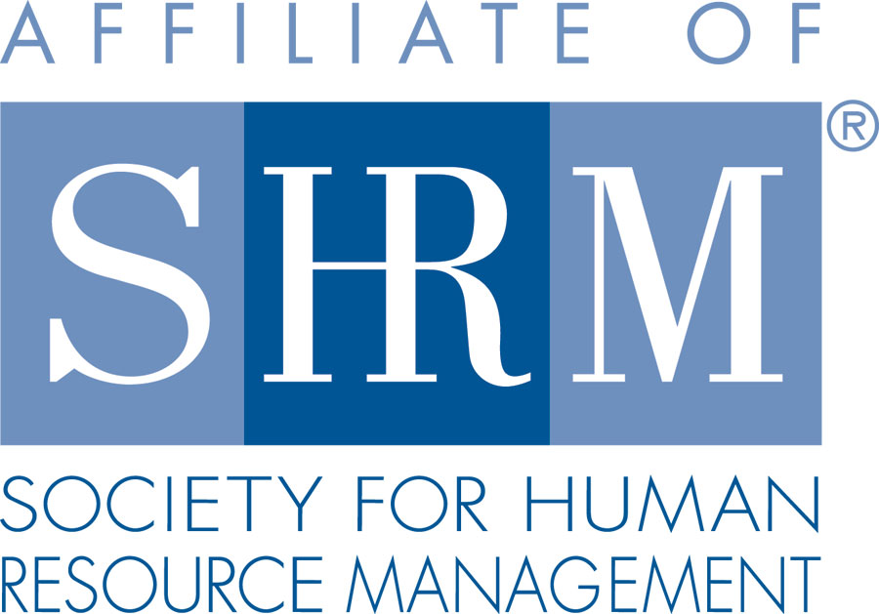 | BERKS COUNTY CHAPTER #179  P. O. Box 55  Temple, PA 19560  Phone: 610-929-3678 www.berkspa.shrm.org | 

BOARD OF DIRECTORS MEETING MINUTES
April 12, 2019
Wyomissing Family Restaurant

Invitees: Shane Keller, Debbie Ramsey, Christopher Holmes, Jenny Batista Jessica Weaknecht, Krista Pauley, Whitney Rahman, Bob Orzechowski, Chuck Holder, Bill Gage, Susan Curtis, Denise Lee, Beth Berrett, Wendy Button, Audra Donato, Bonnie Gruber, Amy Heichel, Nic Thomas

Attendees: Debbie Ramsey, Jenny Batista, Bob Orzechowski, Whitney Rahman, Bonnie Gruber, Nic Thomas, Wendy Button, Chuck Holder, and Denise Lee

- 7:37 am Debbie Ramsey – Called to order
- Approval of the March 19, 2019 Board Meeting Minutes – Jenny Batista and Bob Orzechowski
- Review of March 2019 General Meeting & Lunch and Learn Critiques – Disability Awareness: How HR Can Ensure Onboarding, Retention & Future Planning, Presented by Vondol Hammond & Lavinia Garcia Ritter. Comments: Didn’t know VOL existed, Lavinia is a great speaker, Thank You. 56% stated the program exceeded their expectations. Lunch & Learn: Privacy Issues in the Workplace, Presented by Whitney Rahman Esq. – Looking for more information another meeting on this topic, great information.
- Treasurer’s Report
  - Update – Credit card reader App. for the card reader should be sent in the next week or two.
Opening Balance $28,888.46
Income $1,044.00
Expenses $2,053.18
Ending Balance $27,879.28

- Committees and Chairs:
- Administrator – (Wendy Button) – Website has been completely updated. Voting for the upcoming Secretary is going well about 39 votes have been cast. Working on the Membership Survey, should be sent out beginning of May.
- BCTV (Bob O) – May 2nd next show topic will be – Employee Rights & Discipline. This is the 14th year with BCTV. Station is willing to videotape 10-12 testimonials. 30-45 seconds each, stating what SHRM means to you @ about 200 words, will air during the show and after the show.
- Certification – Study Group (Bob O) – April 11th is the last class, no class the following week and then a mock test the night of the 23rd.
- Scholarship Program – Scholarship would be for the SHRM Exam cost. For SHRM Members who do not receive help from their employers. Want to revisit discussion at the planning meeting.
- Chapter of the Year (Jessica) – No Update

- Compliance (Susan Curtis) – No Update
- Diversity & Inclusion (Denise Lee) – Denise presented some information on the Symposium. Pushing the date to June 25th, location will be at The Double Tree. There will be three speakers, having outside sponsorship to help with the cost of speakers. The Symposium will be a half day program.
- Engagement Committee (Nic Thomas) – Reviewing membership renewals and reaching out to who is left.
- Historian (Open) – No Update.
- Hospitality / Membership (Bill Gage) – Spring Fling still reviewing locations, date etc.
- Legislative/A-Team (Whitney/Audra) – No update
- Marketing Update – Developed a flyer to be ready to handout at the Spring Renewal Expo & Conference. SHRM will be sharing the Chamber’s booth at the Spring Renewal. Discussed taking pictures during the monthly meetings, Whitney to review a disclaimer statement. Wanted for further communication releases: % of successful SHRM Exam Certifications, HR Summit in November, Video Testimonials and our upcoming Spring Fling.
- Programming / Speaker Contact (Krista Pauley) – No Update
- Sponsorship / Community Relations (Chuck Holder) – Chuck mentioned about providing more prospects for sponsorship. We continue to go back to our past sponsors and we need to look at additional opportunities.
- New Business:
  - Volunteer Conferences
August 3, 2019 – HR Change Agent Training –Carlisle, PA
September 19-20 – PA SHRM State Conference, State College
  - Secretary Nomination Process – Alex Goodman & Beth Shartle have been nominated
  - Scholarship – Table till next board meeting
- Next General Meeting – May 14th – Talent Acquisition: Bridging the Law and Effective Practices, presented by Jonathan Segal Esq.
- Lunch and Learn - May 28th – Employees as Caregivers: What Employers Need to Know, Presented by Kevin Moore.
July 23rd – Unconscious Bias, presented by Denise Lee.
- Next Board Meeting – May Board/Planning Meeting, date and time to be announced.

- Motion to adjourn – 8:55 am – Bob Orzechowski and Jenny Batista

