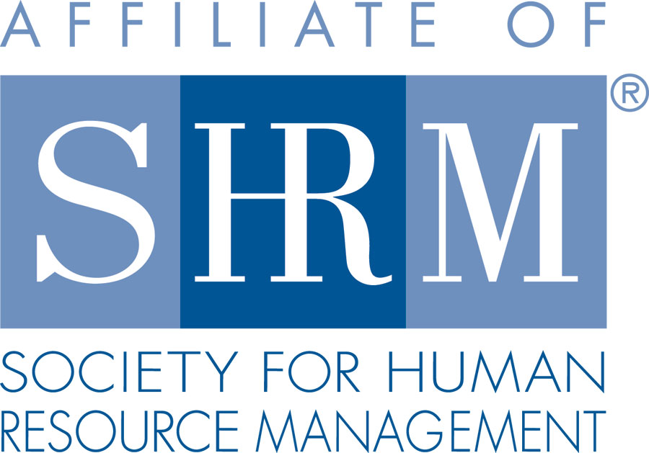 | BERKS COUNTY CHAPTER #179  P. O. Box 55  Temple, PA 19560  Phone: 610-929-3678 www.berkspa.shrm.org | 

BOARD OF DIRECTORS MEETING MINUTES
October 17, 2017
Wyomissing Restaurant & Bakery 7:30 AM

Invitees: Shane Keller, Debbie Ramsey, Christopher Holmes, Jenny Batista, Jessica Weaknecht, Krista Pauley, Whitney Rahman, Bob Orzechowski, Chuck Holder, Bill Gage, Susan Curtis, Denise Lee, Beth Berret, Kelly Kozik, Wendy Button, Audra Donato, Bonnie Gruber

In attendance: Shane, Chris, Jenny, Kelly, Bill, Bob, Whitney, Chuck, Krista, Audra, Debbie, Denise

- Meeting called to order at 7:32am
- September 19, 2017 Meeting Minutes approved - Bob and Deb
- Review of Sept. Meeting Critiques:
  - Microphone – people still can’t hear
    - Speakers should always use a microphone
    - Deb will make sure they choose one type of microphone and not give them an option to use or not use one
    - People liked Chet Mosteller’s presentation
    - There were suggestions for topics
- Treasurer’s Report
  - Reviewed and approved
    - Beginning balance: $15,195.45
    - Income: $1,232.00
    - Expenses: $1,158.80
    - Ending balance: $15,268.65
- Committees and Chairs:
- Administrator – Website (Wendy Button)
  - Website is up to date with the certification tab being a work in progress
- BCTV (Bob O)
  - Nov. 14 next program – Kevin Moore and new attorney Erin Kelly from Roland Stock
    - Drugs in the Workplace – Medical Marijuana
    - Bob is reaching out to someone to possibly talk about opioids

- Certification – Study Group (Bob O)
  - Has gotten 1 or 2 offers from members to be facilitators
  - Historically it’s been on a Thursday but there is no particular night
  - Start date to be end of January 2018
  - Wendy sent out a certification study group survey to gauge interest for the winter/early spring.
  - We have 8 people who have expressed interest so we’ll probably have enough to get the materials at a discounted cost
- Compliance (Susan Curtis) – no update
- Diversity & Inclusion (Denise Lee)
  - Survey and summary has been completed and sent to Wendy to be distributed to the membership
  - Many of the members had commented that they appreciate how much the committee and the chapter does
  - Some committee members have been participating in diversity events such as De Mujer A Mujer, the book club with De Mujer A Mujer, and the Diversity Mixers on a monthly basis
  - We are putting together a proposal for the board – the committee is working on doing some community work
  - Kelly thanked Denise for sharing her diversity story at the meeting
  - When we get ready to do the diversity ball activity at meetings, we need to provide an explanation about the ball so new members and guests understand what we are doing
  - We will start having volunteers to receive the ball and answer the question
  - Denise is attending SHRM Diversity Conference next week
- Engagement Committee (Kelly Kozik)
  - Wendy has provided Bob and Kelly a list of members who did not attend any meetings or lunch sessions from June through October
  - An email is going out to people that have not attended 5 meetings consecutively
  - Committee is reaching out, verbally, to see if there are any new barriers to members not attending meetings
  - We had a table for new members to sit at with Kelly during the meeting
- Historian (Open)
  - We are still looking for someone to take this position
- Hospitality / Membership (Bill Gage)
  - Membership increased from 136 members to 155 members. We are 3rd in new membership among chapters
  - Carolyn is very good at keeping up with National SHRM’s list to ensure their records are correct
  - Wendy mailed 32 membership information letters and applications to the list of companies (provided by Bob) who recently participated in a job fair
  - Wendy also submitted a request to SHRM to email at-large members through their free email program. They require 10 business days to approve and send the email which should go out sometime this week or next week.
  - We have a free table at the HR Summit – They are allowing 1 hour for attendees to visit booths
- Legislative (Whitney Rahman) – nothing to report
- A-Team (Audra) – nothing to report
- Programming / Speaker Contact (Krista Pauley)
  - Lunch & Learns
    - November 28, 2017 – Critical Decision Points in U/C (S. Whitney Rahman, Esq.)
    - January 22, 2018 – FMLA Practical Tools for Tracking & Decision Making (Deb Franklin, Esq.)
    - Krista is wrapping up this year’s speakers
    - We got an email yesterday from US Dept. of Wage and Hour division letting us know that their top person is willing to speak to our group for free – Krista is going to get him booked for next year
    - Krista has gotten communication from speakers that are charging a lot of money – she has thanked them and told them we are full for this year
    - Krista is still trying to work through the meeting with the Chamber/Caron Foundation
- Special Projects
  - PAL Dinner
    - Bonnie was at last meeting and asked for volunteers
  - Holiday Party – January 4, 2018
    - We don’t need to do anything just yet
    - We need to lock down numbers and see how many people are interested
    - Question - Is there a role you want the board to play at the event?
    - Suggestion was made to only have 1 drink ticket included with entry fee
- Sponsorship / Community Relations (Chuck Holder)
  - Provide list of sponsors (calendar) – STATUS
    - PSECU has committed to sponsor a meeting
    - Mark Shearer has sent info in
    - Chuck sent out 2 applications yesterday – we just need 2 more sponsors through May
    - He has abandoned the community project
    - Chuck will reach out to other local chapters to see what they do for community outreach
    - Debbie said last year Gage was asked about hiring a coordinator and they hired Ivy. She is located at Reading High School. The principal is very committed to the students. Gage is committed to have this coordinator help students find jobs. The Jewish Community center helps students to get back on target to graduate.
    - We should partner with Ivy and the high school to help them
    - Whitney suggested to donate a sponsorship to the high school
    - Vision Resource Center, Bill said, if you have any companies that have any work, reach out to them
    - Request from Alvernia for us to distribute flyer to membership on leadership programs
- New Business
  - Bank update – Jenny to have all information to present at next meeting
  - National / PA SHRM meetings (schedule)
    - November 16–18, 2017 - SHRM Leadership Conference, Washington DC
      - Jenny attending
  - SHRM Foundation Committee
    - Do we want to see if interest exists?
    - Do we have enough volunteers as we are currently shorthanded to fill positions?
    - Bob will get together a mission statement
    - Suggestion to do a silent auction or raffles at big meetings and the Holiday Party in order to make a donation
  - Chapter of the Year Committee
    - Do we want to see if interest exists?
    - We get money and recognition for participating
    - Krista suggests that there always be a board member with the person who volunteers to do this to ensure continuity and flow of information
- Next General Meeting - November 14, 2017 – Maria Angelucci – Understanding Medicare
- Bob will finalize the color guard for November’s meeting
- Next Board Meeting – November 21, 2017 at Wyomissing Restaurant and Bakery.
- Meeting adjourned 8:39 – Chuck and Whitney

