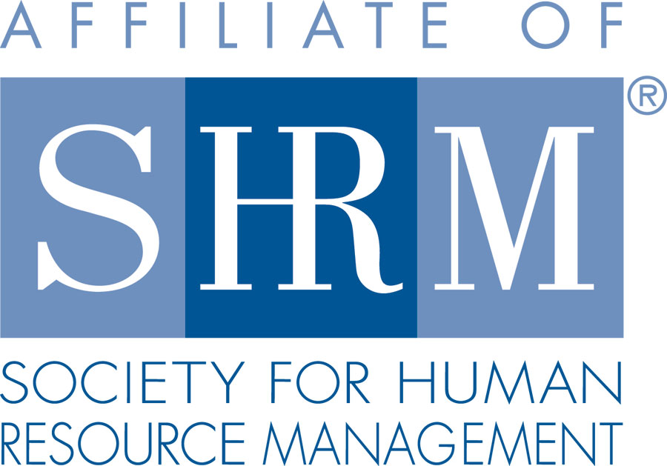 | BERKS COUNTY CHAPTER #179  P. O. Box 55  Temple, PA 19560  Phone: 610-929-3678 www.berkspa.shrm.org | 

BOARD OF DIRECTORS MEETING AGENDA
November 21, 2017
Wyomissing Restaurant & Bakery 7:30 AM

Invitees: Shane Keller, Debbie Ramsey, Christopher Holmes, Jenny Batista, Jessica Weaknecht, Krista Pauley, Whitney Rahman, Bob Orzechowski, Chuck Holder, Bill Gage, Susan Curtis, Denise Lee, Beth Berret, Kelly Kozik, Wendy Button, Audra Donato, Bonnie Gruber, Amy Heichel

In attendance: Debbie Ramsey, Christopher Holmes, Jenny Batista, Kelly Kozik, Bob O., Bonnie Gruber, Whitney Rahman, Chuck Holder, Bill Gage, Krista Pauley

Deb called to order at 7:33am

- Approval of the October 17, 2017 Meeting Minutes.
  - Bob and Chris approved
- Review of November Meeting Critiques.
  - Overall feedback was good
  - Still some comments about the eggs
  - Preemployment testing and records management are some suggested topics for future meeting
- Treasurer’s Report
  - Reviewed & approvee – Bob and Bill
Beginning balance: $15,482.43
Income: $1,967
*Expenses: $3,897.55
Ending balance: $13,551.88
*Note: The expenses were made up primarily from two separate invoices; one from the general meeting fee of over $1,900 and travel reimbursement for Denise’s trip over $1,700.
Note for Denise: The board would like a summary/debrief of the D&I conference
- Committees and Chairs:
- Administrator – Website (Wendy Button) – nothing to add
- BCTV (Bob O) –
  - Show was last week
  - Caron Foundation VP participated
  - We ask that Wendy add the link to the show on our website
    - Wendy please be sure that the link is available to the public
    - You can receive up to 5 credits on the honor system
    - In January, the topic may be on harassment
    - Chet will be on in Feb. or March
    - Chet may have agreed to sponsor 2018 again
- Certification – Study Group (Bob O)
  - ID number for recertification was corrected
  - We need to offer business credits. Bob is discussing with Krista to discuss to get programs to qualify
  - 7 committed to go through the certification – there is a physical limit of about 25 people for the study room
  - Bob would like to see the money for the certification course collected by the end of the year.
  - We buy the study set for the facilitator
  - Deb would like to know if 3 of the 7 people committed for the class are from East Penn
    - Could certification class be an avenue to get new members? Deb suggested that we put out an ad about the certification and make sure to mention that membership is required
    - Bob will draft ad to be placed for this next certification class
    - Jenny asked about giving a small gift to those that pass the test. Bob suggested reimbursing the test fee. Others concerned about the cost.
- Compliance (Susan Curtis) – nothing to add
- Diversity & Inclusion (Denise Lee)
  - Kelly reported
    - We are presenting at the March meeting
    - We will also participate in the BCTV program
    - Helping organizations start a diversity and inclusion program
    - Bob stated that SHRM has a diversity tool kit
- Engagement Committee (Kelly Kozik)
  - Kelly was able to talk to a few people at the last meeting
  - Our committee reached out to people that haven’t been able to get to meetings. Every single person has gotten back to Kelly.
  - As she was talking to students they were very interested
  - Jenny brought back information from the Leaders’ Summit regarding mentoring students to get them engaged and learning about the different committees
    - Kelly and Bob are willing to be mentors to the 2 students from Penn State
- Historian (Amy Heichel)
  - Vote to approve Amy Heichel as Chapter Historian (Chair)
    - Bob – Bylaws state that the President can appoint chairpersons. We don’t normally put it to a vote
    - Bill showed an article and photo of 1972 officers
    - Wendy – can we ask members to provide the year when they joined SHRM Berks Chapter, so we can update our records?
    - Suggestion was to acknowledge members’ anniversaries (when they joined SHRM)
at monthly meetings
- Hospitality / Membership (Bill Gage)
  - Number of members in:
    - 2015 – 137
    - 2016 – 136
    - 2017 – 160
  - Carolyn is very good at checking with Crystal of SHRM to make sure our numbers match
  - Laurie Morgan from Solo Labs referred by Nina Bohn
  - Michael Rasool with East Penn referred by Debbie Ramsey
  - Kelcey Heckrote with East Penn – referred by Debbie Ramsey
  - Leanne Foskey with East Penn referred by Allison Sneider
  - We did not get any response from the letters that went out to employers
  - Members at large also have not responded to our letters
  - The Summit yielded a nice list of people. Denise sent the list to Wendy.
  - Deb – we had a booth but not a lot of fanfare – we may want to do a little bit more. We were in the corner and not highly visible.
  - Small business owners loved it, but there may have been too much time allotted for the vendor visits
  - Krista said they had vendors that didn’t want to return because they didn’t get enough time – this is why they gave more time.
  - Kelly – Nathan Rubright’s company (he is interested in joining) might be interested in sponsoring and he may want to speak at a chapter meeting
- Legislative (Whitney Rahman)
  - Whitney is getting with Audra to do legislative and A-Team reporting together
  - Deb – updates will be valuable for students also
- A-Team (Audra)
  - Please see above
- Programming / Speaker Contact (Krista Pauley)
  - Lunch & Learns
    - November 28, 2017 – Critical Decision Points in U/C (S. Whitney Rahman, Esq.)
    - January 22, 2018 – FMLA Practical Tools for Tracking & Decision Making (Deb Franklin, Esq.)
    - Krista – needs topic from Debbie PSCEU needs a topic.
    - D&I topic is needed
    - Next week’s lunch and learn Wed 11/29 – Deb, Kelly and Chris will get the equipment together
    - Kevin has not been very responsive. We only need 3 people to be a part of the legislative lunch and learn. Bob suggested to pull Erin and Andy in.
    - Whitney will reach out to Kevin
- Special Projects
  - PAL Dinner – Dec. 7
    - Bonnie has people coming to the dinner, has Santa and helper, has milk being donated.
    - Still needs bags – grocery-sized bags to fit things like a blanket, stuffed animals, food, etc.
    - Gino’s Grill is giving us a better deal on the pasta ($20 cheaper than last year)
    - Donations will sometimes go directly to Wendy
    - The chapter may contribute about $100
    - Jenny will get back to Bonnie about taking the photos
  - Holiday Party – January 4, 2018
    - Ideas to engage people and to mingle
    - Chuck suggested a game for people to get to know one another
    - Jenny said D&I Committee wants to do an activity
    - For December meeting we will agree on activities to do at the party to not overwhelm people
    - Recognition for the 45th year
      - We will present it as an anniversary party
    - Wendy please add a “no refund” note to invitations
    - Krista has suggested to charge people in full – no refunds – if they don’t show up
    - Important for Amy to be at our next meeting
    - 56 members and 32 guests have said they were interested in coming
    - $36 per person will be our cost. Charge members $15, $20 for guests
    - Cost to chapter will be almost $2,000
    - Kelly suggested giving only 1 drink ticket included in price – will save a lot of money
    - Group says to keep price the same. Voted on 1 drink ticket.
    - Unlimited soda and water. Bill to purchase wine and beer
    - Menu – can’t spend more than $30 on choices
      - Carving station – beef and turkey
    - Deb asked if we should do a raffle and donate to the foundation for 2018
      - Please bring donation ideas/offers to next BOD meeting
    - Kelly suggested to invite the newspaper to come. And maybe place an ad - Tri-County has done this in the past.
- Sponsorship / Community Relations (Chuck Holder)
  - Provide list of sponsors (calendar) – STATUS - February and March are open
    - $300 / sponsorship
    - $250 for repeat sponsors
  - Still need 2 people for the Spring. Bob sent him information from Lancaster Chapter to possibly get ideas on how to create interest (i.e. different levels of sponsorship)
  - Bob – suggested to reach out to Marketing Dept. at Reading Eagle to possibly be a Sponsor
  - Whitney suggested to share “testimonials” from past sponsors since they have had some success
  - If D&I is going to be in March, Deb suggested to have Ivy (Career program coordinator) be our sponsor – the Reading High program
  - Chuck is meeting with Ivy regarding moving forward on our community service project
  - Kelly’s company just hired 2 students from Reading High
  - Chuck to provide us with a list/calendar of sponsors
- New Business
  - Bank update – Status – Jenny didn’t have a lot of success with the credit unions. We got plenty of information, but they may not be able to meet our needs. Jenny is gathering information from regular banks to add to spreadsheet comparison, so we can compare apples to apples.
  - Berkshire Country Club – 2018 Meeting Date/Contract – Review
    - Bill doesn’t have pricing yet
    - The country club has gotten additional business from addressing the membership twice a year
  - SHRM Foundation Committee
    - What is the decision of the board? Do we want to add this committee?
  - Chapter of the Year Committee
    - What is the decision of the board? Do we want to add this committee?
    - If you want to go for chapter of the year you need a foundation committee
    - Need dedicated people to track things throughout the year – a couple of people to stay organized enough to do it.
    - You get recognition and about $2,000 out of it
    - Qualitative section and quantitative section is included
    - Bob says there is about 30 minutes per month time commitment
      - Discussion - Deb suggested that Wendy send an email to request a volunteer and send the chair job description
      - Discussion - Put paperwork out on tables
      - Discussion - Announce at the meeting
      - Krista thinks it should go to the Past President. Everyone thought this was a great idea
    - Deadline is July 31st to submit paperwork
- Next General Meeting - December 12, 2017 – Heather Chandler – Multigenerational Workforce
- Next Board Meeting – December 19, 2017 at Wyomissing Restaurant and Bakery.
- Motion to adjourn 9:05am – Krista – Chuck

Respectfully submitted by Jenny Batista, Secretary

