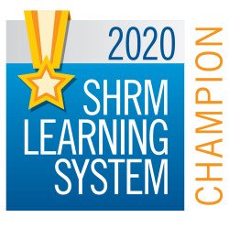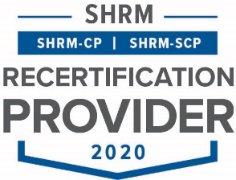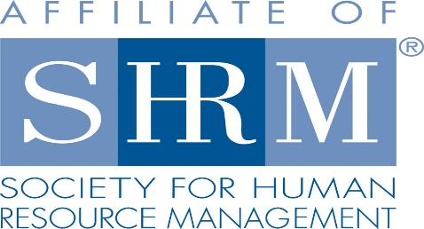

|  |
| --- |
| BERKS COUNTY CHAPTER #179  **P. O. Box 55**  **Temple, PA 19560**  **www.berkspa.shrm.org**  **berkschapter179@gmail.com** |

**BOARD OF DIRECTORS MEETING MINUTES**

**December 15, 2020**

**Via ZOOM**

Join Zoom Meeting   
<https://zoom.us/j/91435557846?pwd=dHRCcVJVeUlQR2ZxaUF5eGxqa1JPZz09>

Meeting ID: 914 3555 7846   
Passcode: 408232   
One tap mobile   
+13017158592,,91435557846#,,,,,,0#,,408232# US (Washington D.C)   
+13126266799,,91435557846#,,,,,,0#,,408232# US (Chicago)

Invitees: Shane Keller, Jenny Batista, Bonnie Gruber, Beth Shartle, Debbie Ramsey, Krista Pauley, Whitney Rahman, Bob Orzechowski, Chuck Holder, Bill Gage, Susan Curtis, Denise Lee, Beth Berrett, Wendy Button, Audra Donato, Nic Thomas, Claudia Wert, Melissa Rebholz, Maddie Hertzog

Attendees: Jenny Batista, Bonnie Gruber, Beth Shartle, Debbie Ramsey, Bob Orzechowski, Bill Gage, Wendy Button, Nic Thomas, Claudia Wert, Maddie Hertzog

1. **Approval of the November 17, 2020 Board Meeting Minutes**
   1. Motion made by Bob, seconded by Beth
2. **Review of December 8, 2020 General Meeting Critiques: “Drive Business Success w3ith Workplace Flexibility” with Gloria Sinclair Miller**
   1. TABLED – Jenny will add these to the Board meeting AFTER the month in which the meeting occurred to allow time to gather information.
3. **Treasurer’s Report**

Opening Balance $17,857.62

Income $0

Expenses $1,614.12

Ending Balance $16,243.50 (includes D&I)

Helping Harvest donations to date: $3,020.00

1. **Committees and Chairs:**
2. Administrator – Website (Wendy Button) – everything is up to date. Wendy just sent out the survey regarding interest for the Winter Certification classes.
3. BCTV (Bob O) – January 12 is next program with Chet Mosteller – topic: Succession Planning / HR Planning in COVID Era
4. Certification – Study Group (Bob O) – Awaiting survey results regarding participation interest
5. Chapter of the Year (Jessica/Debbie) – no update
6. Compliance (Susan Curtis) – no update
7. Diversity & Inclusion (Denise Lee) - no update
8. Engagement Committee/Marketing (Nic Thomas) – discussion regarding Berks SHRM logo. Wendy will send out a poll to the membership to have them vote.
9. Historian (Claudia Wert) – committee compiled history of SHRM National and will add 2 paragraphs about the SHRM Berks Chapter. They reached out to a chapter in South Jersey and another in New Mexico that had celebrated a 50th anniversary. Committee also looked at a report regarding the top 50 people in HR over the last 100 years to share.
10. Hospitality / Membership (Bill Gage) – further discussion on Patty Burke with Spotts, Stevens, Mccoy – membership criteria
    * Patty Burke with Spotts, Stevens, McCoy. Her title is Sr. Executive and Admin Assistant. Her primary responsibilities are in support of the H R Department. 3
    * Bill will get more details on Patty’s support role in the HR Department.
    * Regarding membership numbers:
      1. Dec. 2018: 156 members
      2. Dec. 2019: 155 members
      3. March 2020: 159 members
      4. June 2020: 160 members
      5. Sept. 2020: 132 members
      6. We lost 23 National members
      7. 10 local members did not rejoin
      8. Bill will discuss with Nic and Wendy to see about asking these 10 local members the reason they did not rejoin
      9. Bob O. “we always try to have a 95% retention rate”
11. Legislative/A-Team (Whitney/Audra) – no update
12. Programming / Speaker Contact (Krista Pauley) – no update
13. Sponsorship / Community Relations (Chuck Holder)
    * Bob O will sponsor January’s general meeting
    * Mark Shearer will sponsor February’s general meeting
14. PAL Dinner (Debbie Ramsey)
    * Debbie had sent an email regarding putting any further action on hold until the Olivet Boys and Girls Club reopens
15. Foundation (Maddie Hertzog)
    * Welcome Maddie! Maddie will be meeting with Bob O for guidance on how to proceed
    * Please add her email address to your contact list: mhertzog@pennstatehealth.psu.edu
16. **New Business:** 
    1. Bob O. – Develop position on recognition of past and upcoming sponsors of virtual meetings
       * Jenny to send out draft that Bob had proposed we send to the membership
    2. Nic – Berks Chapter Logo
       * Please see report under “Engagement Committee”
17. **Next General Meeting –** January 12, 2021 – “Succession Planning – More Important Now Than Ever” with Chet Mosteller and Laurel Cline - via ZOOM
18. **Lunch and Learn Sessions: 11:30a – 12:30pm**

* January 26, 2021 – “FMLA Update: New Trends and Old Traditions” – Grace Bond, Esq. Blakinger Thomas Law Firm - via ZOOM
* Bob says we have PDCs through the January Lunch and Learn but nothing further. He’s working with Krista on this.

1. **Future PA SHRM meetings/dates**
   1. April 29, 2021 – 1:00pm – In-person meeting, Best Western Hotel, Harrisburg, PA
   2. April 30, 2021 – All day – L&L Conference, Best Western Hotel, Harrisburg, PA
   3. July 23, 2021 – 2:00pm – In-person meeting, Seven Springs Resort, Champion PA
   4. July 24, 2021 – All day – PA Leadership Conference, Seven Springs Resort, Champion, PA
   5. September 22, 2021 – 2:00pm – In-person meeting, Penn State, State College, PA
   6. September 23, 2021 - 1 ½ days – PA SHRM State Conference, State College, PA
2. **Next Board Meeting –** January 19, 2020 via ZOOM
3. **Motion to adjourn –** Bob motioned; Beth seconded. Meeting adjourned at 8:28am

Meeting minutes respectfully submitted by Jenny Batista, President