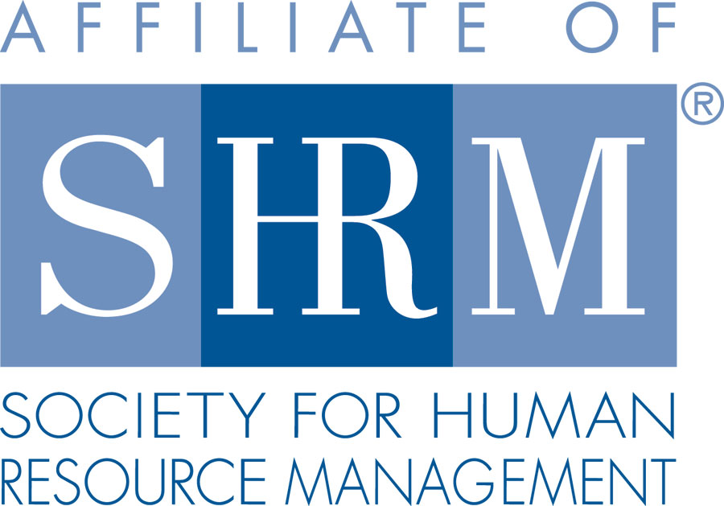 | BERKS COUNTY CHAPTER #179  P. O. Box 55  Temple, PA 19560  Phone: 610-929-3678 www.berkspa.shrm.org | 

BOARD OF DIRECTORS MEETING MINUTES
December 19, 2017
Wyomissing Restaurant & Bakery 7:30 AM

Invitees: Shane Keller, Debbie Ramsey, Christopher Holmes, Jenny Batista, Jessica Weaknecht, Krista Pauley, Whitney Rahman, Bob Orzechowski, Chuck Holder, Bill Gage, Susan Curtis, Denise Lee, Beth Berret, Kelly Kozik, Wendy Button, Audra Donato, Bonnie Gruber, Amy Heichel

In attendance: Shane, Debbie, Chris, Jenny, Jessica, Whitney, Bob, Chuck, Bill, Denise, Kelly, Wendy, Bonnie, Amy

- Meeting called to order at 7:30am
- Approval of the November 21, 2017 Meeting Minutes. – Bob and Jessica
- Review of December Meeting Critiques.
  - From Lunch and Learn – everyone enjoyed Whitney’s presentation
  - Last meeting – positive remarks on Heather’s presentation
  - We should keep in mind that we can have Heather speak on another topic
  - Future speaker topic suggestion - recruiting
- Treasurer’s Report
  - Review & approve
Beginning: $13,151.81
Income: $3,733.00
Expenses: $1,825.02
Ending balance: $15,059.79
- Committees and Chairs:
- Administrator – Website (Wendy Button)
  - Wendy is putting out one last call for certification – January 4 is due date
  - 4 people have paid for certification (we had 9 people sign up)
- BCTV (Bob O)
  - Last program was done in November
  - Next one on January 9th. Topic will be sexual harassment.
  - March – Diversity
  - May – probably Chet
    - Chet sponsors ($1,000) BCTV
    - Producer fee due in Fall ($100)
  - Sent out emails for Kevin Moore but he is not available
  - It’s always good to have attorneys on the panel
  - Put out an email to Lou McCoy
- Certification – Study Group (Bob O)
  - Wendy will put out one more notice
  - Bob is reaching out to previous facilitators to see if they are interested again in teaching a class
  - Newly certified members expressed interest
  - Looking at first Thursday in February (2nd) to start class
  - Testing window early May – late June
- Compliance (Susan Curtis)
  - CLIF report was submitted within deadline. We are compliant.
- Diversity & Inclusion (Denise Lee)
  - One of the things we are working on is a flyer to provide people information on our committee
  - We are still working on it because the graphic we used may not be released for public use
  - We set up our own email address
    - diberksshrm@gmail.com
  - We’ll put together a display for the holiday party
- Engagement Committee (Kelly Kozik)
  - Kelly heard from one of our new members (a student at Penn State) – he’s interested in different committees. She will meet with him to talk about this.
  - Everyone that Kelly had on her list regarding not attending meeting, she has heard back from
  - Bob had 3 people get back to him.
    - People typically couldn’t attend meeting due to conflicts but Bob suggested they think about joining a committee
  - Suggestion made by Jenny – to let people know time commitment so maybe they will want to join a committee
  - Kelly will re-word letter that goes out to include this information
- Historian (Amy Heichel)
  - Appointment of Amy Heichel as chair
    - Amy asked anything that anyone would like to contribute she can put together in a display
    - Suggestion to list presidents for past several years
    - Wendy and Steve Bell had done a presentation in the past. Wendy will send info to Amy.
    - Amy’s email address: Heichel.amy@gmail.com
    - Suggestion to contact people in the article that Bill had provided (past presidents)
    - Kelly asked about a paid ad in the 422 Business paper – we don’t think we want to pay for an ad
    - Bob has an ad to share with the Reading Eagle
    - Amy has connections with the Reading Eagle and may be able to reach out
- Hospitality / Membership (Bill Gage)
  - We’ve been getting a pretty steady flow of new members
  - $14/person, $50 for the screen – contract has been signed with the Berkshire Country Club
- Legislative (Whitney Rahman)
  - There should be a lot of information for the update next month
  - Audra and Whitney have been getting together to get the A-Team combined with the legislative update
- A-Team (Audra) – see update above
- Programming / Speaker Contact (Krista Pauley)
  - Lunch & Learns
    - January 23, 2018 – FMLA Practical Tools for Tracking & Decision Making (Deb Franklin, Esq.)
  - Whitney asked Wendy to send her suggestions on programming
  - Debbie said Habitat for Humanity wants to present something at the meeting
- Special Projects
  - Holiday Party – January 4, 2018
    - 88 people responded that they were coming to party
    - We are now at 43 that have paid
    - We need to pick our food for the party
    - Bill will get with Whitney and choose
    - We are giving 1 drink ticket to each person attending
    - Bob asked for 2 tables - for historian and for D&I Committee
    - Another email going out today to remind everyone about the party
- Sponsorship / Community Relations (Chuck Holder)
  - Provide list of sponsors (calendar) – STATUS
  - Community service project is moving ahead
    - Had discussions with former Vice Principal at Reading High. Also spoke with Ivy Horn from Gage Personnel – who
    - Meeting with someone from Alvernia and Jim Shankweiler from Penn State
    - Still need a couple of sponsors for the Spring
    - Wendy sent Chuck the full list of sponsors – Chuck will get this out to the Board
    - Reading High confirmed for March
    - Whitney suggested giving a reminder to sponsors that they only have 5 minutes to speak
  - Good turnout of PAL dinner
    - Bonnie gave update
    - A coworker played an elf and did a great job
    - Enersys helped with bagging gifts
    - Crafts were ordered from Oriental Trading and went over well
    - About 100 children attended
    - Santa was from Enersys
    - Jenny will send pictures to group, so we get some on the website
    - Whitney suggested not putting any photos of children on website
- New Business
  - Bank update – What is the status
    - Jenny talked about fees for PayPal
    - We need to make sure Whitney looks at the contract which is what the problem was last time this type of payment system was reviewed
    - Jenny will provide additional information at next meeting
  - Annual Dues Renewals
    - Review/Approve the attached - approved
    - Deadline of January 15 discussed – if they are not paid by March they cannot attend as a member
- Next General Meeting - January 9, 2018 – Janel Cross – The Cost of an Under-Utilized 401k Program - Why Outcomes Matter Most
  - How will we let members know if we are canceling meeting – email and on LinkedIn
  - Wendy to add info to email reminders
- Bonnie has expressed interest in putting together information for Chapter of the Year
  - Bob talked about the quantitative/qualitative component of it
  - Shane appointed Jessica the chair for the Chapter of the Year committee to work with Bonnie
  - Bob suggested using a repository for paperwork – like Base Camp or Google Docs, Dropbox
  - Amy asked Bob about the Foundation Committee
  - Suggestion to do a raffle at the January meeting – Bonnie will bring tickets

- Next Board Meeting – January 16. 2018 at Wyomissing Restaurant and Bakery.
- Motion to adjourn 8:40am – Bob and Deb

Respectfully submitted by Jenny Batista, Secretary

