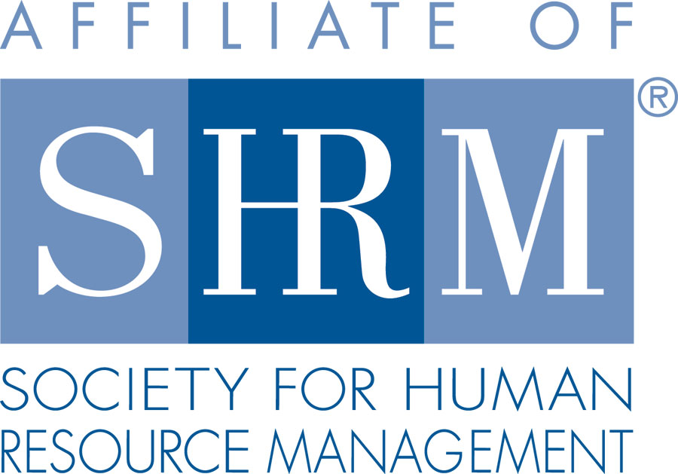 | BERKS COUNTY CHAPTER #179  P. O. Box 55  Temple, PA 19560  Phone: 610-929-3678 www.berkspa.shrm.org | 

BOARD OF DIRECTORS MEETING AGENDA
June 20, 2017
Conference Call – 1-866-370-1666 | Access code: 7964665:

Invitees: Shane Keller, Debbie Ramsey, Christopher Holmes, Jenny Batista, Jessica Weaknecht, Krista Pauley, Whitney Rahman, Bob Orzechowski, Chuck Holder, Bill Gage, Susan Curtis, Denise Lee, Beth Berret, Wendy Button

In Attendance: Shane, Krista, Bob, Denise, Debbie, Bill, Whitney, Jess, Chuck

- Called to order at 7:35 AM
- Approval of the May 31, 2017 Planning Meeting Minutes. Debbie 1st, Krista 2nd.
- Review of June Meeting Critiques. Positive comments on the speaker. Room was cold. Difficult to hear the speaker (again). Should incorporate a sound check and make the microphone mandatory. Equal Opportunity election Process Law and HR Record Management were suggested as future topics.
- Treasurer’s Report – TABLED, Chris was not on the conference call.
  - Review & approve
  - Approve May Treasurer’s Report (tabled at Planning Meeting)
  - Bob has suggested that we see two consecutive 12 month periods, preferably for the past 2 calendar years so we can make better decisions regarding cash flow, and to address potential member concerns about our current balance.
- Committees and Chairs:
- Administrator – Website (Wendy Button)
  - D&I page looks fantastic. Wendy did a great job organizing thing.
- BCTV (Bob O)
  - July 11th is next program. Steve Bell and Bob have a few topics. Employee Rights & Discipline. Hoping to get an attorney on the show as well.
- Certification – Study Group (Bob O)
  - Bob feels we should put out a feeler now to gauge interest for a fall group. We should be ordering materials in late July. Wendy has the notices and would just need to change the dates.
- Compliance (Susan Curtis)
  - Are we tax-exempt? If so, what is the tax-exempt number? – Bill confirmed that we do have a tax-exempt certificate. Waiting for a copy that will be shared with the board.
- Diversity & Inclusion (Denise Lee)
  - 26 responses so far to the survey. Will be asking Wendy to resend the link to keep it in front of everyone. Committee would like to do a presentation in March. Looking at a few options, including case studies, role-plays, speed learning, etc. In the process of planning what the presentation will look like. The committee is also interested in conducting a Lunch & Learn and is researching potential topics now.
  - SHRM D&I Conference attendance – Denise feels much can be gained by her attendance at the conference and is asking for the board’s commitment and financial support to send someone. Spend should be around $3,000.00 when factoring in airfare, hotel, and meals. Debbie 1st, Shane 2nd. Motion carries.
- Engagement Committee (Bob O)
  - Kelly Kozik has expressed interest in chairing the committee. Bob will follow up with her directly.
  - Quiet for now. Will send another email in August pestering those that have not attended.
- Historian (Open) – No report
- Hospitality / Membership (Bill Gage)
  - Holiday Party – January 4, 2018 – Stirling wants a minimum of $30.00 PP. Once tax and gratuity is factored in, would be close to $45 or $50 pp. Need to discuss amounts to charge for members and guests. Bob feels non-members should be charged enough to cover their costs, but we discount members as we see fit. We should offer a cash bar, not an open bar. Discussed what insurance the chapter has – do we have liability or just officer’s coverage? We have paid for insurance – Debbie will work with Chris to see what the policy covers.
  - Karen Kramer, Director of Organizational & Talent Development. Works for Remcon Plastics. National Member and PHR Certified. Approved.
  - BCC – At current rates, we are charged $17.80 and we charge $18.00. We are pretty much break-even for what we charge our members for breakfast. We occasionally do not meet the 50-person minimum and have to pay the minimum.
  - For members that RSVP for meetings and do not show, are we tracking and invoicing? We will add to the agenda each month to track.
  - Chapter designation forms. Carolyn Weaver sends the form and the electronic instructions to new members. Need to devise a system to track on a monthly basis who has returned the forms and who has not. Bill and his committee will be going back in time to audit to make sure SHRM National has everyone logged.
  - Bill will be picking up DD gift cards for the referral program.
- Legislative (Whitney Rahman)
  - Lunch & Learns – in past years, we scheduled three at a time at the end of the year’s cycle so comments from critiques could be included in the planning. We have additional people that have expressed an interest in conducting these going forward. Whitney will work up a conference call in July to move this forward and get next year scheduled.
  - Audra getting involved with the A-Team. Has sent information to Whitney that she is reviewing. We should consider adding Audra to the general meeting agenda to provide updates. The A-Team is SHRM’s advocacy group. Audra would be the point to provide updates to the chapter.
- A-Team (Audra)
- Programming / Speaker Contact (Krista Pauley)
  - Speakers locked down. Still waiting for confirmation on July’s presentation from Mosteller. The rest of this year, as well as January & February of 2018 are also locked down.
- Special Projects
- Sponsorship / Community Relations (Chuck Holder)
  - Provide list of sponsors (calendar) – Chet tentatively for September. Has tentative sponsors for October, November, December. Goal is to have everyone set up by labor day. Awaiting confirmations for a few more. Once completed, will get a schedule delivered to everyone.
  - Still working on the business in Reading/Berks County initiative. Working on getting a third meeting set up with the powers that be. Chuck will keep trying.
  - Previous sponsor – Chuck will have a list out to everyone by next Tuesday.
- New Business
  - Bank update
    - Status of new signature cards – still working on it.
  - Board Member/Committee Chair of the Month
    - I will need bios. Wendy?
      - Shane will ask Wendy to send the bio sheet to the committee chairs. We will start these introductions in the coming months.
  - Board Calendar of Events
    - Monthly items needed
  - National / PA SHRM meetings (schedule)
    - July 28, 2017 - In-person, Gettysburg, PA – Bob is attending
    - July 29, 2017 - PA SHRM Leadership Conference – Bob is attending
    - September 20, 2017 - In person, The Penn Stater, State College, PA
    - September 21- 22, 2017 - PA SHRM State Conference, State College, PA
    - November 16–18, 2017 - SHRM Leadership Conference, Washington DC
- Next General Meeting is July 11, 2017 – Mosteller and Associates will be providing a speaker. Topic TBD
- Next Board Meeting - Tuesday, July 18, 2017 at Wyomissing Restaurant and Bakery.
- Adjourned at 8:27 AM – Krista 1st, Debbie 2nd.

