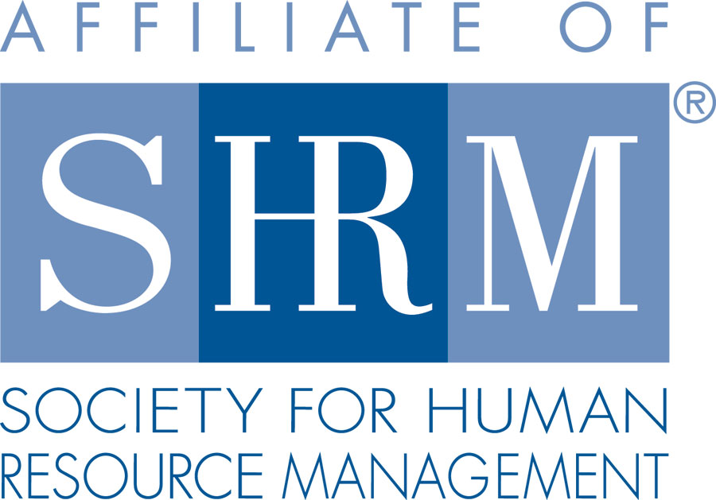 | BERKS COUNTY CHAPTER #179  P. O. Box 55  Temple, PA 19560  Phone: 610-929-3678 www.berkspa.shrm.org | 

BOARD OF DIRECTORS MEETING MINUTES
July 18, 2017
Wyomissing Restaurant & Bakery 7:30 AM

Invitees: Shane Keller, Debbie Ramsey, Christopher Holmes, Jenny Batista, Jessica Weaknecht, Krista Pauley, Whitney Rahman, Bob Orzechowski, Chuck Holder, Bill Gage, Susan Curtis, Denise Lee, Beth Berret, Wendy Button

Present: Shane Keller, Debbie Ramsey, Chris Holmes, Jenny Batista, Jessica Weaknecht,
Bob O., Bill Gage, Kelly Kozik

- Called to order at 7:33am
- Approval of the June 20, 2017 Meeting Minutes - Debbie and Bob
- Review of July Meeting Critiques.
  - Everything was really nice.
  - One comment about lack of water on the tables
  - Lots of comments about the difficulty hearing
  - Chris met with someone so we can hook up the technology effectively. The head set works best. For the questions, an option was to put a mic stand in the middle of the room so people can get up and step up to the mic. We may have to buy a piece for the clicker (for presentations) in order to advance slides remotely.
  - Positive feedback on the speakers
- Treasurer’s Report
  - Reviewed and approved report for July (as of midmonth)
    - Beginning Balance: $23,189.13
    - Income: $822.00
    - Expenses: $1,698.76
    - Ending Balance: $22,698.76
    - Chris will run some of the reports comparing prior year(s) to current year
    - Bob talked about the Berks County Community Foundation having money to offer – there is a Diversity Alliance Endowment Fund being offered. Application must be received by Aug. 15 to be shared with Denise – Jenny will share
- Committees and Chairs:
- Administrator – Website (Wendy Button) – no updates
- BCTV (Bob O)
  - Bob got Jeff Elliot involved – Employee rights and discipline. Hopefully we can get Andrew to participate in the next show. Bob likes to have an attorney involved.
  - It’s a low cost, high-value add for members
  - Received no call-ins with questions
  - Bob does fill out a form that indicates what should go on the press release that goes to the newspaper for advertising
- Certification – Study Group (Bob O)
  - We’ve only gotten 2 people that are interested in the study group
  - 1 person didn’t pass – unsure of how many have taken the test out of the 9 people that took the previous class
  - Not sure if we’ll have enough people for the Fall program
  - There is a press release that comes with the program so you can announce that you’ve passed the test. Bob also asked participants to let him know who has passed.
- Compliance (Susan Curtis) – no update
  - Are we tax-exempt? If so, what is the tax-exempt number?
  - We are an affiliate – for the Berks Community Foundation – we may need to look into this
- Diversity & Inclusion (Denise Lee)
  - 46 surveys received
  - Good feedback
  - Committee is working on coming up with an action plan to address some of the items on the survey
- Engagement Committee (Bob O)
  - Kelly Kozik is taking over as chairperson of the committee
  - Beth and Ramona remain active and engaged
  - We should come out with an announcement that Kelly is taking over – get to Wendy
  - Twice a year we send emails for people who didn’t come to 4 consecutive meetings
  - Kelly – SHRM National has a pretty robust page on engagement. She has ideas from other SHRM Chapters
- Historian (Open)
  - Bob – we’ve had information out there before
  - The main charge would be to retain the history and relics
  - 45 years as a group (in Sept.)
  - We should do something – a small giveaway to the membership to celebrate anniversary
  - May be the 45th anniversary is a good time to reignite interest in this area
- Hospitality / Membership (Bill Gage)
  - Dunkin Donut referrals – 3 gift cards were given
  - 2 new members
    - Katie Driscoll referred Zoe Sianis
    - Catherine Krohn
- Cost for breakfast – we are breaking even
    - We are charging people that register and don’t make it to the meeting
- Discussed sources of revenue and expenses
- PA CareerLink had sponsored us for several years. Chet Mosteller has done it for the past 2 years.
- We are still looking to Chuck and Wendy to see who our sponsors have been.
- Bill asked if we have had feedback on how our sponsors feel about their expectations. Chuck may want to ask sponsors after their sponsorship
- Legislative (Whitney Rahman) – no update
- A-Team (Audra) – no update
- Programming / Speaker Contact (Krista Pauley)
  - Krista sent Bob a list for PDCs – just missing October
- Special Projects
  - Holiday Party – January 4, 2018 (Thursday)
  - We need to talk about what we will be offering (food, drinks)
- Sponsorship / Community Relations (Chuck Holder) – no update
  - Provide list of sponsors (calendar)
    - We need history on who has sponsored in the past and the list of sponsors going forward
- New Business
  - Bank update
    - Status of new signature cards – update to be taken care of in the near future
  - Board Member/Committee Chair of the Month
    - Wendy has what is currently on the website that covers board members
    - Committee Chairs – we need bios on committee chairs
  - Board Calendar of Events
    - Monthly items needed
  - National / PA SHRM meetings (schedule)
    - July 28, 2017 - In-person, Gettysburg, PA – Bob is attending
    - July 29, 2017 - PA SHRM Leadership Conference – Bob is attending
    - September 20, 2017 - In person, The Penn Stater, State College, PA – Kelly may be able to go
    - September 21- 22, 2017 - PA SHRM State Conference, State College, PA
    - November 16–18, 2017 - SHRM Leadership Conference, Washington DC
- Next General Meeting is August 8, 2017 – Drew Parenti, Vice President of Security for Penske Truck Leasing and Damond Kloc, Security Manager for Penske Truck Leasing will present, “A Safer Workplace: Preventing Workplace Violence.”
- Next Board Meeting - Tuesday, August 15, 2017 at 7:30am at Wyomissing Restaurant and Bakery.
- Next Tuesday (July 25) is the next Lunch and learn
- Adjourned at 8:19am – Debbie and Bill

