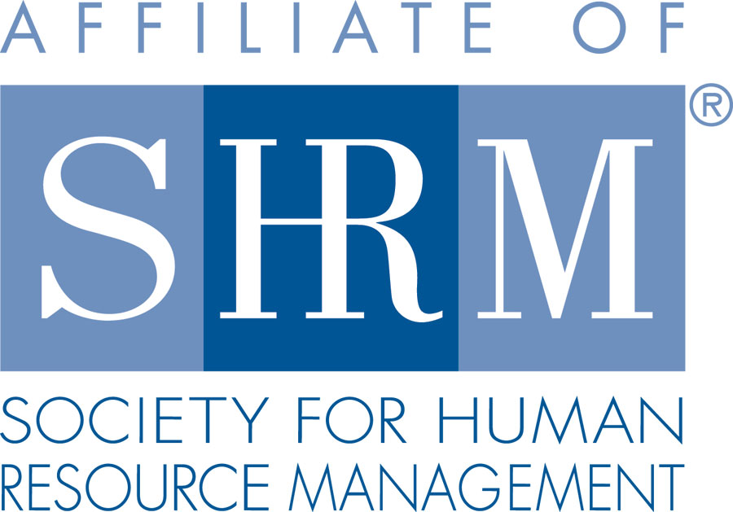 | BERKS COUNTY CHAPTER #179  P. O. Box 55  Temple, PA 19560  Phone: 610-929-3678 www.berkspa.shrm.org | 

BOARD OF DIRECTORS MEETING MINUTES
August 15, 2017
Wyomissing Restaurant & Bakery 7:30 AM

Invitees: Shane Keller, Debbie Ramsey, Christopher Holmes, Jenny Batista, Jessica Weaknecht, Krista Pauley, Whitney Rahman, Bob Orzechowski, Chuck Holder, Bill Gage, Susan Curtis, Denise Lee, Beth Berret, Kelly Kozik, Wendy Button

In attendance: Bob O., Kelly Kozik, Shane Keller, Debbie Ramsey, Krista Pauley, Chris Holmes, Denise Lee, Chuck Holder

- Meeting called to order at 7:33am
- Approval of the July 18, 2017 Meeting Minutes. Krista, Bob approved
- Review of August Meeting Critiques.
  - Excellent speaker, good eggs (breakfast), need a 2nd microphone for question/answer period. People were happy that the microphones were used.
  - We should ask for the presentation slides as they are not always provided.
  - July lunch and learn was well received. Whitney proposed a few scenarios and the group worked through them.
  - Kelly mentioned the high caliber of the presentation that we had at the August meeting
- Treasurer’s Report
  - Review & approve – tabled due to technical issues
- Committees and Chairs:
- Administrator – Website (Wendy Button) – website is current
- BCTV (Bob O)
  - Normally for the Sept. 12 program they run a condensed version of the Sept. meeting
  - Has gotten an “out of office” message from Andrew. Bob will see if he can have a backup in case Andrew can’t make it.
  - For November meeting, Bob is trying to put together a panel on medical marijuana issue.
  - Twice a year they are running producer meetings at Albright.
  - On letterhead, we are preferred provider – Bob asked about having that. Asked about a banner also to put on the table
- Certification – Study Group (Bob O)
  - There were about 2 people that were interested. Bob offered to do private sessions since we didn’t have a group.
  - Need reminders for people to let us know if they’ve gotten their certification – our group gets money for it.
  - Needs bios for lunch and learns – Krista says she does have some information already
  - Chapter of the year award – you get points for how many strategic credits you’ve earned. Bob is looking into this
  - We will start asking people about their interest in joining the study group in October in order to start in January.
- Compliance (Susan Curtis) – nothing to report
- Diversity & Inclusion (Denise Lee) –
  - We are getting together as a committee and dig into results of survey and put together a report to present in Oct. We had 46 people that responded to the survey.
  - Does the Board need to see the minutes?
  - Still reaching out to some of the other chapters to see if we could do things with them
  - Paypal? Chris will look into the bank and see if we can set up some type of electronic form of payment
  - Group has been networking within the community
- Engagement Committee (Kelly Kozik)
  - One new member, Cheryl, met with Kelly after August meeting and Kelly answered questions
  - Bob shared his process regarding new member communication and following up with people who have not attended meetings and keeping committee engaged by dividing up the outreach
- Historian (Open)
  - Update from Bob O. Recent member inquiry
  - Connected with Amy Heischel – waiting for a date to meet on this
  - Goal is to create a database with the information we need from members to collect information and start tracking past officers. We had that back in 2004/2005.
- Hospitality / Membership (Bill Gage) – no update
- Legislative (Whitney Rahman) – no update
- A-Team (Audra) – no update
- Programming / Speaker Contact (Krista Pauley)
  - Lunch & Learns
    - September 26, 2017 – Reasonable Accommodation & Case Study Review (Vondol Hammond & Lavinia Ritter)
    - November 28, 2017 – Critical Decision Points in U/C (S. Whitney Rahman, Esq.)
    - January 22, 2018 – FMLA Practical Tools for Tracking & Decision Making (Deb Franklin, Esq.)
  - Updated meeting schedule
  - Meeting with Debbie and her crew to see what they are doing
  - Partnering with Chamber – regarding the Opioid issue. Krista asked for a takeaway for the HR professionals
    - Looking to do a breakfast at the country club
    - Have Caron Foundation talk about issues they are seeing
    - How it’s affecting productivity at work, etc.
    - Giving sample policies on substance abuse
    - Actual presentation would be 1 ½ hrs.
    - Conversation is ongoing regarding the logistics of the meeting (i.e. fees, income, etc.)
    - Chamber wants this done ASAP (Oct. or Nov.)
    - This would be done in addition to the Summit
    - Krista wants to do the flyer and provide the link through our website and let us run it
    - Jennifer Martin emailed Krista asking about our travel policy – Shane and Bob to check on that
- Special Projects
- Holiday Party – January 4, 2018 – no update
- Sponsorship / Community Relations (Chuck Holder)
  - Provide list of sponsors (calendar) – STATUS needed
  - Goal was to have the whole year reserved and paid for by Labor Day
  - ½ the meetings committed to sponsorship but have not paid
  - Most people that are sponsoring are return sponsors
  - Bob talked about how they worked it at Gettysburg – you get a discount for repeat sponsorship.
  - We have 5 of 9 sponsors that have committed
  - Community service that Chuck has been working on – Shane Paisely who owns Design Revolution – revitalizing Reading, block by block. This would get us back into the community.
    - Chuck reached out to Shane and asked him to make a commitment.
    - If he can’t commit we are asking to run with it – put our name behind it to be part of the community in Berks County.
    - Chuck will ask what our involvement would be
    - He will also ask Shane Paisley to put together a presentation to the Board showing what the program is about
- New Business
  - Bank update
    - No update
  - National / PA SHRM meetings (schedule)
    - September 20, 2017 - In person, The Penn Stater, State College, PA - Bob will attend
    - September 21- 22, 2017 - PA SHRM State Conference, State College, PA Bob will attemd
    - November 16–18, 2017 - SHRM Leadership Conference, Washington DC -
  - SHRM Foundation Committee
    - Bob asked us to put together a Foundation Committee – you get points for a Foundation Committee
    - Chapter of the Year has an important component to the foundation
    - State council is 3rd or 4th in the country for the foundation
    - It’s not a lot to do – SHRM gives you specifics for it
    - We need to get the word out to the membership about the work the foundation does
    - Bob has items to raffle off if we decide to do this
    - Krista raised questions about financials associated with raising funds, getting volunteers
    - Chris suggested if we can’t get a committee together the Board can take it on
    - Bob will put together a mission statement and additional info on this
  - Caron Foundation – Requested Partial Credit for missed meeting
    - We denied request based on current practice
      - Do we want to revisit invoicing for no shows at monthly meeting?
      - No, we are not revisiting
  - BCTV Octoberfest donation request
    - $50 prepaid card – Deb will get
  - Gettysburg conference report; Bob O.
    - State council gave their budget
    - Bob’s 3 takeaways
      - Develop webinars
      - Recommend a foundation chair for our chapter
      - Advertise to gain members based on our value equation
    - A program on WOW service
      - Describe a positive experience and a time we failed to measure up to our members’ expectations – Bob suggested we add it to our board meetings and planning meeting
      - Bob suggested that board members sit among the group at meetings instead of sitting together
      - A lot of people had data on 1 – 3-year members. Bob doesn’t think we’ve ever done a turnover analysis – of the people that don’t renew, how long have they been with us? For the SHAPE report, we have a retention goal and growth goal.
      - We don’t know where our turnover is. We need to start measuring it. If a majority of our turnover is within that 1 – 3-year mark, we need to do something about it in order to improve retention.
      - Chuck suggested that Wendy ask for updated information from members stating that the average email address lasts 18 months.
      - Shane agrees that it makes sense and will ask Wendy to do
      - Some chapters pay for or contribute towards SHRM certifications if they pass it. Bob suggested that we give something toward the certification fee if they pass
      - Another metric we should have – 30% of members need to be SHRM members in order to be an affiliate. Next year that number is going to be 50%
      - Chapter charter – we can get information from Crystal Adair
      - Suggestion to put on the screen during our meetings – to show the Chapter mission and vision statements.

  - Chapter-of-the-Year update; Bob O.
    - Is on a point system
    - If there is a tie, they go to a qualitative aspect
    - We have 74 points. The average points to get Chapter of the Year is 150 points
    - Bob says he doesn’t have all the information he needs to know where we may have additional points.
    - Everyone was given a copy of the requirements so we can let Bob know what contributions each of us can make towards this qualification.
  - Veteran’s Job Fair Attendee List question
    - Bob attended a job fair on May 31st. 74 companies, 9 institutions – only about 30 or 35 were Chapter members
    - Bob shared a list
    - Communication should come from Chapter 179

- Next General Meeting is September 12, 2017 – Andrew Howe, Esq. – Legal & Legislative Update

- Next Board Meeting - Tuesday, September 19, 2017 at Wyomissing Restaurant and Bakery.

- 9:14am - Motion to adjourn Chris and Bob

