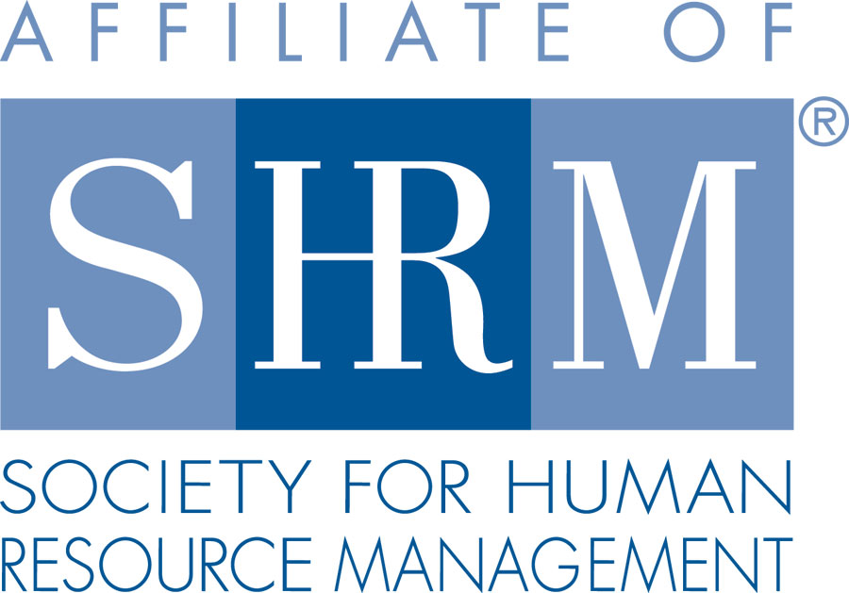 | BERKS COUNTY CHAPTER #179  P. O. Box 55  Temple, PA 19560  Phone: 610-929-3678 www.berkspa.shrm.org | 

BOARD OF DIRECTORS MEETING MINUTES
September 19, 2017
Wyomissing Restaurant & Bakery 7:30 AM

Invitees: Shane Keller, Debbie Ramsey, Christopher Holmes, Jenny Batista, Jessica Weaknecht, Krista Pauley, Whitney Rahman, Bob Orzechowski, Chuck Holder, Bill Gage, Susan Curtis, Denise Lee, Beth Berret, Kelly Kozik, Wendy Button, Audra Donato, Bonnie Gruber

In attendance: Shane, Chris, Jenny, Jessica, Debbie, Krista, Bob, Chuck, Bill, Kelly, Wendy

- Meeting called to order at 7:38am
- August 15, 2017 Meeting Minutes approved - Chris and Bob
- Review of September Meeting Critiques.
  - Overall, everyone was happy
  - Someone asked for a jitney from the parking lot
  - Krista asked for Nora’s critiques (Engaging your Workforce) from November 2015 (approximately)
- Treasurer’s Report
  - Reviewed and approved
    - Beginning balance: $14,485.37
    - Income: $1,194
    - Expenses: $1,780
    - Ending balance: $13,899.37
- Committees and Chairs:
- Administrator – Website (Wendy Button)
  - Everything on the website is up to date
  - Wendy added a new tab to include information on certification
  - Shane talked about adding a tab on our website for each committee to get information out
  - Wendy to get the non-attendee list to Kelly
  - Suggestion to announce the dress code for meetings (no jeans) as we had someone attend a meeting in jeans
- BCTV (Bob O)
  - Bob would like to have a banner and table cloth for the BCTV shows – Jenny to check items in bins and provide Bob what he needs
  - Bob reported on the great technology that they are currently using including a green screen where we can project an image of the SHRM logo
  - Last program went well
  - For November, we are looking at Drug-Free workplace, medical marijuana – from a workplace perspective
  - Kevin Moore will be there
  - Bob is still trying to get someone from the medical society to help
  - January is generally when Chet Mosteller is featured (underwriters)
  - We will touch on union issues at one of the shows – any ideas are welcome – be factual and not take sides
  - Kelly suggested integrated negotiations as a section – Bob wants to make sure we stay neutral with our discussions/presentation
- Certification – Study Group (Bob O)
  - Putting the call out for interest – looking to announce at Oct. meeting – to have interest before the holidays and have first class before the end of January 2018. We need at least 5 people to get discounted materials.
- Compliance (Susan Curtis) – no update
- Diversity & Inclusion (Denise Lee) –
  - Kelly – National Hispanic Heritage month – posted something on website for group’s participation and discussion
  - Bob suggested “English Only Rules” as a topic. This may be a better topic for legal.
  - In October, we are holding an extended meeting (2 hours) to devote one full hour to the D&I Survey results and determine what action items we will tackle in the near future.
  - Erin Kelly – Bob suggested we invite this new member to join committee (Lawyer)
- Engagement Committee (Kelly Kozik)
  - We had 3 new people attend meeting – Gretchen, Adam and Erin
  - Kelly will send the welcome email out to them
  - Suggestion was made to have a specific area for new members to meet with the engagement committee – to have a sign so they can stop before the meeting. An engagement person should sit at this table in order to help guide them through their first meeting.
  - Also suggested for the sponsors’ table to be easily accessible to membership, maybe to put across from registration table
- Historian (Open)
  - Bob trying to get together with Amy Heichel regarding the Historian position
- Hospitality / Membership (Bill Gage)
  - The Dunkin Donuts gift card is working fine
  - Chapter designation – Carolyn Weaver has been working on this. We found out that national associations weren’t being designated properly.
  - Twice a year we can send information to at-large members – in October and May – information to include lunch and learn information, the meeting calendar, etc.
  - Another group to send to – all employers that currently are not represented in the membership
- Legislative (Whitney Rahman) – no update
- A-Team (Audra) – no update
- Programming / Speaker Contact (Krista Pauley)
  - Debbie – speaking on identity theft
  - Krista is emailing Jonathan to get him on deck
  - Lunch & Learns
    - September 26, 2017 – Reasonable Accommodation & Case Study Review (Vondol Hammond & Lavinia Ritter) – approximately 25 people currently signed up
    - November 28, 2017 – Critical Decision Points in U/C (S. Whitney Rahman, Esq.)
    - January 22, 2018 – FMLA Practical Tools for Tracking & Decision Making (Deb Franklin, Esq.)
    - Chamber is under way – Krista is working on clarification from Chamber regarding their presentation
    - The Hershey HR Conference is on Nov. 28 – the same date as the lunch and learn – we may need to move the lunch and learn
- Special Projects
  - PAL Dinner
    - Debbie had a conversation with Bonnie and she is interested again.
    - Bonnie reaching out to the club to verify date of PAL dinner
  - Holiday Party – January 4, 2018
    - Sending out a “save the date”
- Sponsorship / Community Relations (Chuck Holder)
  - Provide list of sponsors (calendar) – STATUS – Chuck will provide as soon as possible
  - PSECU for May
  - He will get the list of sponsors for the last few years to us
  - Wendy will be sending out a thank you for sponsors’ participation
  - Wendy is gathering the bios and photos
  - Alvernia already signed up to sponsor
  - $300 for first time sponsor
  - $250 for return sponsor
  - No one has complained about the cost
  - Bob suggested on working with WorkNet
  - Back to square one on the community project.
  - Bob talked about Jim Shankweiler working on community health and living a healthy lifestyle – meeting with him on Friday to get more details
- New Business
  - Bank update – What is the status?
    - Nothing – the bank is giving us the run around just to add Jenny as a signer
    - We will go to current members’ banks/credit unions
    - Jenny will gather information from banks to determine who will best meet our needs
    - Bob suggested that we do RFPs to be fair
  - Email Blast for At-Large Members
  - National / PA SHRM meetings (schedule)
    - September 20, 2017 - In person, The Penn Stater, State College, PA
    - September 21- 22, 2017 - PA SHRM State Conference, State College, PA
    - November 16–18, 2017 - SHRM Leadership Conference, Washington DC
  - SHRM Foundation Committee – Bob will come up with a mission statement and list out what is needed –
    - Chapter of the Year Committee – Bob says the state council gives money for this
    - Bob says everyone should take an item from the list of requirements and keep track of it in order to meet the requirements
- Shane suggested to have a table for a committee for each general meeting so they can explain what they do and for people to be more comfortable joining
- Next General Meeting - October 10, 2017 – Chet Mosteller – Engaging the Workforce
- Next Board Meeting - October 17, 2017 at Wyomissing Restaurant and Bakery
- For Nov. meeting Bob will work on doing the color-guard in honor of Veteran’s Day
- Bill – suggested allowing the country club to talk twice a year and hand out their brochures
- Missing meetings – Bill asked how often communication goes out. Bob says 3 times a year
- Bill asked about committee members sending in their bio and pictures – Wendy checking on participation
- Wendy suggested highlighting a committee member each month
- Motion to adjourn 8:37am – Krista and Bob

