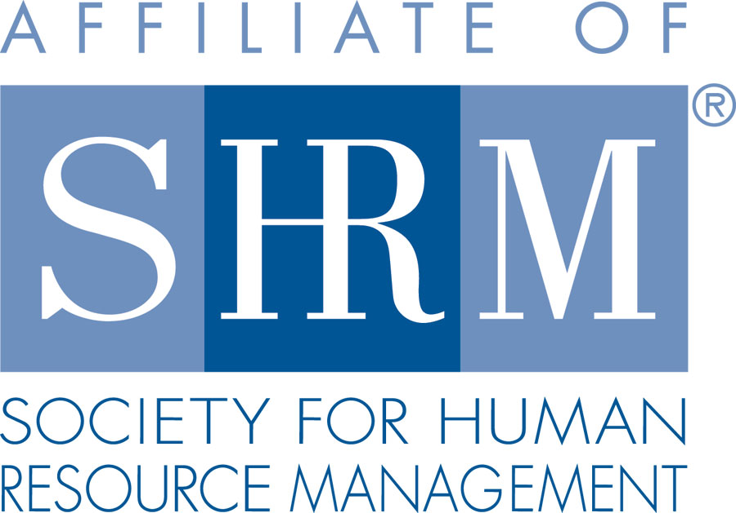
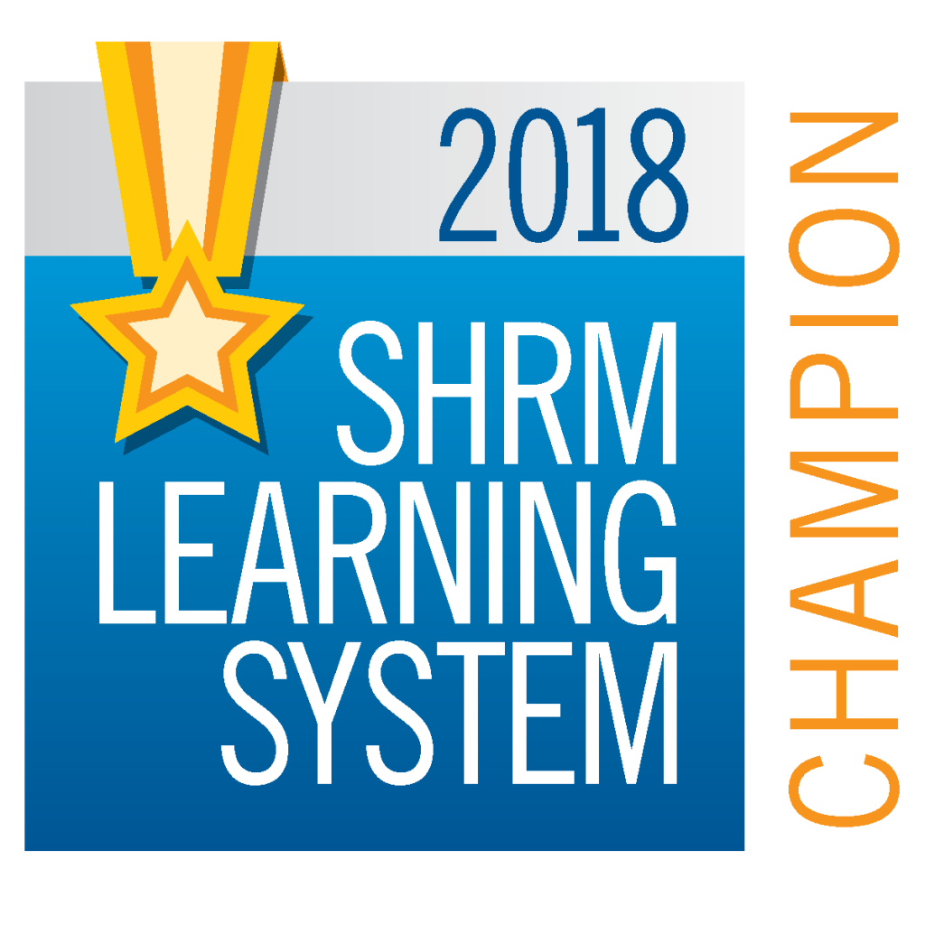
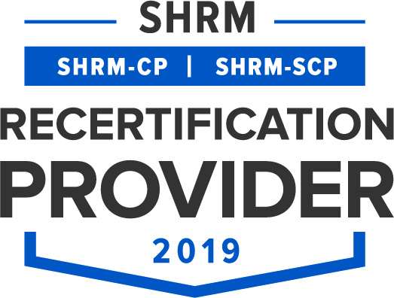
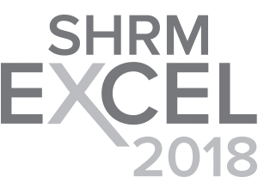

BERKS COUNTY CHAPTER #179
P. O. Box 55, Temple, PA 19560
www.berkspa.shrm.org
berkschapter179@gmail.com

BOARD OF DIRECTORS MEETING MINUTES
September 22, 2020
via Conference Call

Invitees: Shane Keller, Jenny Batista, Bonnie Gruber, Beth Shartle, Melissa Rebholz, Debbie Ramsey, Krista Pauley, Whitney Rahman, Bob Orzechowski, Chuck Holder, Bill Gage, Susan Curtis, Denise Lee, Beth Berrett, Wendy Button, Audra Donato, Nic Thomas, Claudia Wert

Attendees: Shane Keller, Jenny Batista, Beth Shartle, Melissa Rebholz, Debbie Ramsey, Krista Pauley, Whitney Rahman, Bob Orzechowski, Bill Gage, Denise Lee, Nic Thomas

- Meeting called to order at 7:33 am by Jenny
- Treasurer’s Report
Opening Balance - $ 21,543.97
Income - $ 2,400.97
Expenses - $ 2,813.06
Ending Balance - $ 21,131.88 **includes D&I balance

- Committees and Chairs:
- Administrator – Website (Wendy Button not present - Jenny provided an update for her)
  - The website is up to date.
  - Letters sent to those named on the Chamber’s top 25 list 2 weeks ago
  - Letters will be sent today to those named on Chamber’s top 50 in Reading
  - Chuck will provide an updated sponsors list by end of the week
- BCTV (Bob O)
  - August 31st - “Employment Law: Concerns and Issues in the COVID-19 Era” taped. Presented by Joan London of Kozloff Stoudt Attorneys.
  - November 10th Topic - Andrew Howe will be the next panelist to provide a deeper dive into the 9/15//20 legal updates. If required to record remoted, Jenny will host using Zoom if needed.

- Certification – Study Group (Bob O)
  - Those who showed interest in certification in the Fall 2020 got an email offering some help to those who are working on studying
  - Mid-November a request will go out to see who may want to start a winter 2021 group with a 1 hour zoom meeting a week for 13 weeks; if there are 6 people interested, a study group will be created; a facilitator team is available to help as needed to keep supporting it as a mission of our chapter;
- Chapter of the Year (Jessica/Debbie)
  - 7 chapters were nominated, and we did not win; we will try again next year
- Compliance (Susan Curtis)
  - Not in attendance; no update
- Diversity & Inclusion (Denise Lee)
  - Planning a committee meeting next week
  - Considering a D&I series virtually soon
  - Bob O recommended a Blog series for members and that will be discussed
- Engagement Committee/Marketing (Nic Thomas)
  - Email survey sent out to national members who did not join the Berks Chapter; 30% responded of the 88 emails; most responded that they did not join our chapter because of their schedule, their workload, or they moved into a new position.
  - Nic asked if we will be posting the link to recorded meetings in the future for HCI/ SHRM credits; Bob and Krista will look into requirements for credits to be issued; lots for us to consider (i.e. can we edit recordings to meet the needs for credits to be issued with adding polls and proving attendance).
  - Linked In – we now have 58 followers on our page; reminder to share posts to help with traffic and followers.
  - Tom Hubric is interested in helping with committees if there is a need.
  - Zoom etiquette - during the September meeting was a discussion for the board; Jenny is taking steps to encourage and remind attendees to mute; difficult to encourage interaction for networking with muting all participants but it may be necessary.
- Historian (Claudia Wert)
- not able to attend
- she attended the quarterly PA SHRM meeting and has a report to share to everyone
- Hospitality / Membership (Bill Gage)
  - Members at large – Casey Moser and Heather Hellman are now members after reaching out to 12 on this list at large
  - Top 50 list from chamber – 48 actually on the list and outreach will be going out soon
  - National SHRM reported our members as follows:
Dec 2018 =156
Dec 2019 =155
March 2020=159
June 2020 =160

- Legislative / A-Team (Whitney/Audra)
  - No Legislative Updates to report
  - Wendy sent an A-Team update recently
- Programming / Speaker Contact (Krista Pauley)
  - She sent an updated speaker list out this morning
  - Discussion items:
      - Active Shooter topic will be rescheduled since speaker is not available now
      - Krista will reach out to OSHA to be a speaker – it’s been a while since they presented
      - Some speakers still do not want to travel
      - Bob O will compile a few local speakers for the list to consider if needed
      - Krista will send out today’s credit info
      - Ratings for Andy Howe’s presentation need to be reviewed and sent for the group to review
- Sponsorship / Community Relations (Chuck Holder)
- Not able to attend
- A report will be coming out be end of next week from Chuck
- New Business:
    - CLIF report - due December 1, 2020
Discussion items:
      - Wendy normally drafts the CLIF report for everyone’s input
      - Melissa should add the CLIF report to the list of duties by the Administrative Director for responsibilities
      - We do CLIF report as a chapter mid-year and other reports done have the same information on them
    - Committee Volunteers
We have members who have shown interest in assisting with committees and need volunteers from the committees to reach out to invite them to join the committees.
      - Tina Toso - new (returning) member – looking for time commitments. 484-336-8462 or tinatoso14@gmail.com

      - Heidi Shafer – 610-777-7691 or hshaffer@trsinc.org Hospitality/Membership & Certification / Study Group (Bob will find out if she is certified or Maybe Claudia needs more help?)

      - Kim Keith – 610-916-3868 or kkeith@brenntag.com Hospitality/Membership & Historian (Claudia may be able to reach out to her)

      - Beth Shartle – 610-693-8515 or b_shartle@conradweiser.org Certification/Study Group & PAL Dinner

      - Bob Orzechowski – 610-780-0181 or robertorze@gmail.com Community Relations, Special Projects, Certification/Study Group, D&I, Historian, BCTV Panelist & SHRM Foundation

      - Diana Vavreck – 484-332-1352 or dianavavreck@comcast.net Hospitality/Membership & D&I Committee (Denise will reach out to her)
      - Laurie Dawkins – 610-670-9960 or ldawkins1960@gmail.com Community Relations (Jenny will ask Chuck to reach out to her)

      - Michele Goodin – 717-666-9541 or mgoodin@newpenn.com Available to assist in any committee needed (Bob will find out if she is certified or Maybe Claudia needs more help?)

- Next General Meeting:

Date: October 13, 2020
Topic: COVID-19 and HIPAA
Presenter: Bob Orzechowski
Location: Zoom - virtual PDC event

- Lunch and Learn Sessions:
September 22, 2020 - “Interrupting Unconscious Bias” - Denise Lee, Mosteller & Associates - via ZOOM
November 24, 2020 - “Making Cents of Wage Payment, Collection Law & Minimum Wage Act” – Susanna Foultz, Esq., Leisawitz Heller – Location TBD
January 26, 2021 - “FMLA Update: New Trends and Old Traditions” – Grace Bond, Esq. Blakinger Thomas Law Firm – Location TBD

- Future PA SHRM Meetings / Dates
Jenny will do all she can to attend the quarterly meetings. We should be representing our chapter at each of the dates.

November 19 –21, 2020 Volunteer Leader Business Meeting, National Harbor, MD
April 29, 2021 –1:00pm In-person meeting, Best Western Hotel, Harrisburg, PA
April 30, 2021 –All day L&L Conference, Best Western Hotel, Harrisburg, PA
July 23, 2021 –2:00pm In-person meeting, Seven Springs Resort, Champion PA
July 24, 2021 – All day PA Leadership Conference, Seven Springs Resort, Champion, PA
Sept 22, 2021–2:00pm In-person meeting, Penn State, State College, PA
Sept 23, 2021 -1 ½ days PA SHRM State Conference, State College, PA

- Next Board Meeting – October 20, 2020

- Motion to adjourn @ 8:30 am - (Bob / Beth)

