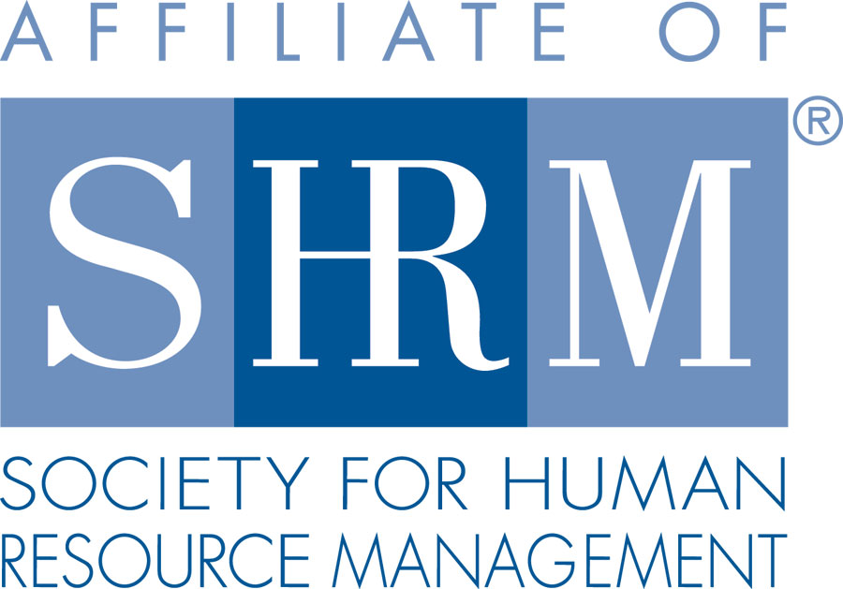 | BERKS COUNTY CHAPTER #179  P. O. Box 55  Temple, PA 19560  Phone: 610-929-3678 www.berkspa.shrm.org | 

BOARD OF DIRECTORS MEETING MINUTES – PLANNING MEETING
May 31, 2017
Viva – 901 Hill Avenue, Wyomissing, PA 19601 - 3:30 pm to 5:00 pm

The 2017 SHRM Berks Chapter 179 Annual Planning meeting was held at Viva restaurant to plan and discuss events for the 2017-2018 program year. The meeting was called to order at 3:40pm

Attendees: Shane Keller, Debbie Ramsey, Christopher Holmes, Jenny Batista, Krista Pauley, Whitney Rahman, Bob Orzechowski, Chuck Holder, Bill Gage, Denise Lee, Wendy Button.
Absent: Jessica Weaknecht, Beth Berret, Susan Curtis

- Approval of the April 18. 2017 Board Meeting Minutes – approved by Krista and Deb
- Review Chapter Survey results –
  - Suggestion was made to communicate a handful of questions/actions during monthly meeting to show the importance of the survey and what actions are being taken as a result of membership’s feedback.
  - Another suggestion was to communicate the holiday party. Bill volunteered to head up the holiday party planning. Venue suggestions – Double Tree, The Sterling. It was discussed to charge a nominal fee in advance In order to ensure commitment from people. January 4th possible date
  - One comment addressed that we have an unsolicited question at a meeting asked from the membership to promote engagement
  - Another suggestion was made to show how to get to LinkedIn and our web page during the first few minutes of a monthly meeting
  - Use of survey monkey for the meeting critiques? Charge is ~$230 annual fee. Deb motioned and Chris 2nd to keep survey monkey.
  - Survey Monkey going forward – we will also continue the use of Survey Monkey for additional feedback throughout the year
- Treasurer’s Report
  - Review and Approve Expenses and Budget April 2017
    - Beginning Balance: $21,515.55
    - Total income: $4,845.00
    - Expenses: $2,789.82
    - Ending Balance: $23,570.73
    - Suggestion was made to add the financial report to our website – for members only to view – in order to better understand how our money is used
  - Monthly meeting charge
    - Members and Nonmember Fee (monthly)
      - Decision was to freeze the cost for 2017 - 2018
      - Talked about student chapters
        - Suggestion to reach out to Beth to see how we can better partner with Alvernia
    - Annual Dues Charge – no increase
    - Meeting Location – keep the same
- Committees and Chairs:
- Administrator – Website (Wendy Button)
  - CLIF Report – no report
  - Any changes needed to website: Adding financials for members’-only view
- BCTV (Bob O)
  - Chapter involvement – what is needed?
BCTV - 117 programs going and all programs are live-streaming
      - Can watch on honor system and get up to 5 credits
      - Reaches 100,000 homes
      - They have special show options
        - iPod touch - we can borrow and we can have a couple of questions to ask people coming to meetings and have a bank of testimonials
  - Fees – Producer’s fee $100 – no change
- Certification – Study Group (Bob O)
  - Plan
    - We had 9 people in last class
    - Everyone liked the variety of facilitators
    - They took a mock final at the last session and then the following week took another mock final that they reviewed
      - Another tool – Quizlet – has a bank of questions, flash cards, etc.
    - Offer another class?
      - Testing is early December – we need 12 weeks for classes
        - Gauging interest – classes to be announced at June and July meetings
        - 15% discount if you get 5 or more / Bill offers up his location for classes
        - Motion from Chris and Debbie 2nd to gauge interest for Fall classes
- Compliance (Susan Curtis)
  - Status – no report
- Diversity & Inclusion (Denise Lee)
  - Finalizing survey to be sent to membership, to be sent to board for final approval, then to be forwarded to Wendy to distribute
  - Christy Gage has offered a $25 gift card to be given away to one person among survey participants
  - Diversity networking event at Winery is being discussed
  - Try to make connections with other D&I committees / groups
  - Different D&I members will give the update at the SHRM meetings

- Engagement Committee (Bob O)
- Continue New Member Orientations
    - Monthly – no problem to do this 15 minutes after each meeting
    - Website access
    - We reached out to 30 people who hadn’t renewed.
    - Twice a year we reach out to people who don’t go to 5 meetings in a row
      - 65 people were on this list
      - Wendy to provide Bob an updated list of members for Bob’s committee to reach out to quarterly
      - Suggestion to change the lunch and learn day
      - Can we find someone to chair the engagement committee?
        - Wendy will put out a blast email explaining what is needed
- Historian (Open) – no report
- Hospitality / Membership (Bill Gage)
  - Goal to increase membership - maybe offer a gift card for referrers to hand out at meetings
    - Offer $10 gift card for coffee
    - 3 new applications received and approved for membership
  - % of increase – goal is 3% growth
    - March Madness – to increase membership – to be done in Feb.
  - Goal to maintain current membership – 3% retention
  - We have new letterhead that has the new gold chapter award included
  - New members – Bill is going to follow up and check into our membership numbers on SHRM’s report for accuracy
  - Wendy is sending out an email to guests thanking them for attending a meeting and letting them know how to join if interested
- Legislative (Whitney Rahman)
  - If we want to go for the chapter of the year designation we have to clarify some things
  - Lunch and Learns went fine
    - We did 6 for the year
    - We’ll start planning for next year
- Programming / Speaker Contact (Krista Pauley)
  - Discuss calendar and speakers
    - On survey Shane talked about people’s need for training on Recruiting and retention – we may have a speaker to address this
    - Krista is working on additional meetings topics/speakers, currently has five open spots through August, 2018
    - Debbie Perini – PSECU – Krista reached out to see what topic they’d like to cover
    - Denise Lee and D&I
    - Problem with partnering other chapters is we have meetings during the same time
    - We’ll discuss lunch and learns further

- Special Projects
- Shape Report – March Madness - project
    - Goals – 3% growth, 3% retention
    - Fundraising ideas
      - Basket Raffles – open up to membership if their company has anything they’d like to contribute (i.e. Godiva, Double Tree, etc.)
      - Pass a hat – at National events collecting money – goes to SHRM Foundation – goes to scholarships
- Sponsorship / Community Relations (Chuck Holder)
    - Sponsorship - 1 person canceled, 2nd guy did not show
- Provide list of sponsors (calendar)
  - Chuck will have the whole year next year filled and paid for in advance
  - Community Relations
    - Meeting has been rescheduled for next week – working on initiative to improve the perception in Berks County
- New Business
  - By-Laws
    - Review and determine if any changes need to be made
      - Clarification on membership for someone who is unemployed but looking for work in the HR field. This seems to be a hot topic each time it comes up. Can we agree on a go forward approach?
        - Bob talked about our accommodation history how we got to associate member. They can come to meetings as guests – we don’t need to set a number – it would be self-regulated – they don’t get to vote.
        - Suggested to create an “operations manual” to talk about how we do things
        - Majority in favor of keeping the bylaws the same. Deb motioned, Krista 2nd.
  - National / PA SHRM meetings (schedule)
    - June 18–21, 2017 - SHRM National Conference & Exhibition, New Orleans – Jenny is attending
    - July 28, 2017 - In-person, Gettysburg, PA - Bob is attending
    - July 29, 2017 - PA SHRM Leadership Conference – Bob is attending
    - September 20, 2017 - In person, The Penn Stater, State College, PA – Bob is attending
    - September 21- 22, 2017 - PA SHRM State Conference, State College, PA – Bob is attending
    - November 16–18, 2017 - SHRM Leadership Conference, Washington DC –
      - Tabling to see who can go
  - Bank update
    - New signature cards:
      - We’ll make arrangements to add Jenny to signature cards
  - Board Member/Committee Chair of the Month
    - Either self-introduction or President reads bio – 1 each month. Increase visibility of who we are – increase transparency to members. –
      - President to read
      - Suggestion to announce and do something additional when recognizing volunteers – maybe at Holiday party - in order to allow more time
  - Digital Strategy Committee
    - Do we need? Should we solicit a volunteer to chair?
    - To identify if / what is needed
      - Suggestion for Wendy to send out an email gauging interest
      - Review our LinkedIn page to see if we are engaging prospective members
        - Is LinkedIn page only for our members?
        - If so, should we open the LinkedIn page up for non-members?
  - Board Calendar of Events (monthly items needed)
    - We were looking at each committee member to see what is needed each month to put into a calendar – to make sure things get done on a timely basis and for succession planning
  - Board Meetings will remain the 3rd Tuesday of each month at Wyomissing Restaurant and Bakery starting at 7:30 AM.
- Next General Meeting is June 13, 2017 – Detective Bob Long – Spring Township Police Department – The Impact of Fraud on the Human Resources Professional in 2017.
- Next Board Meeting - Tuesday, June 20th at Wyomissing Family Restaurant.
- Motion made to adjourn and approved by Krista and Bill

