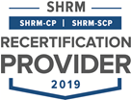 | 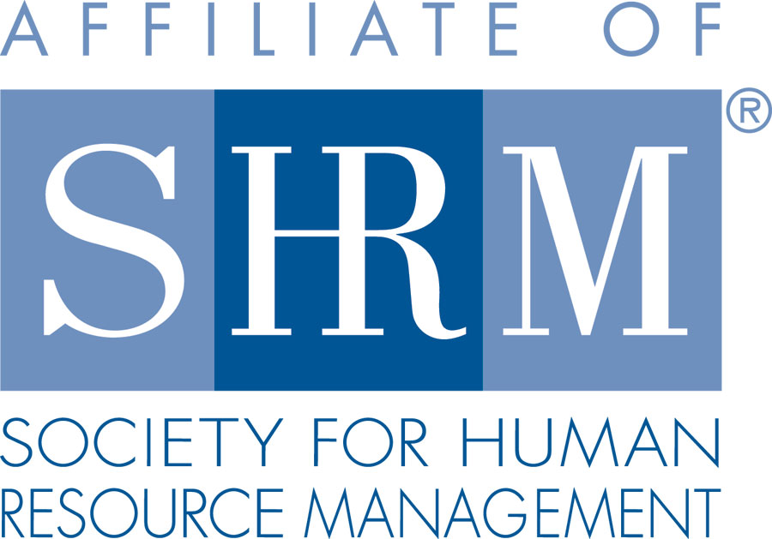 | 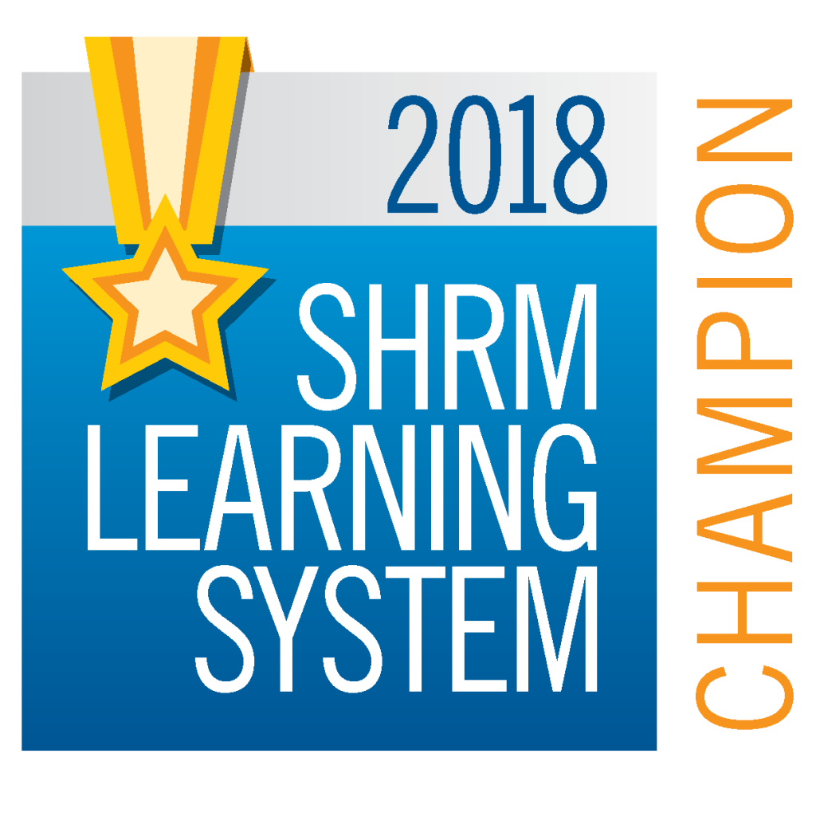

BERKS COUNTY CHAPTER #179
P. O. Box 55
Temple, PA 19560
Phone: 610-929-3678 www.berkspa.shrm.org

BOARD OF DIRECTORS MEETING Minutes
February 26, 2019
Wyomissing Family Restaurant

Invitees: Shane Keller, Debbie Ramsey, Christopher Holmes, Jenny Batista, Jessica Weaknecht, Krista Pauley, Whitney Rahman, Bob Orzechowski, Chuck Holder, Bill Gage, Susan Curtis, Denise Lee, Beth Berrett, Wendy Button, Audra Donato, Bonnie Gruber, Amy Heichel

In attendance: Shane Keller, Bob O., Debbie Ramsey, Jenny Batista, Krista Pauley, Whitney Rahman, Bill Gage, Nic Thomas

- Approval of the January 15th Board Meeting Minutes - Bob and Shane motioned
- Review of January Lunch & Learn, and February 2019 General Meeting Critiques
  - Lunch & Learn: Met but not exceeded
  - General Meeting:
    - A little too basic for the crowd
    - Like lunch meetings
    - Appreciate the credits
    - Majority were middle of the road
    - Not enough solutions offered
    - Better received than the Lunch and Learn she did
  - Suggested topics:
    - Unemployment
    - Employee relations
    - Employee write-ups

- Treasurer’s Report
  - Update – Any new info on the card reader? No update
Opening Balance $14,749.55
Income $16,804.87
Expenses $7,499.96
Ending Balance $24,054.46
- Some explanation of larger amounts:
  - $5,939.87 of income was the transfer of money from M&T so it’s not really income
  - Membership dues totaled $7,256
  - Certification class was another large amount $1,150
  - Largest expense was for certification materials $4,327.02

- Committees and Chairs:
- Administrator – Website (Wendy Button) Membership application complete. New tools from SHRM; Email, mailing list.
  - Wendy attended a webinar by the California SHRM
  - 1 tool – email to reach out to at large members, increase member numbers and retention
- BCTV (Bob O)
  - Kevin Moore and Lou McCoy are on deck as panel members
  - Next one is March 12 – Handbooks & Manuals
  - In May – 401k, Communication – Bob Wert
- Certification – Study Group (Bob O)
  - 4 classes so far
  - 14 planned
  - Next one is Camilla and Alex Goodman
  - Beth Dobransky is on March 7 with Bob
- Chapter of the Year (Jessica)
  - Be sure to update Wendy if you attend anything
- Compliance (Susan Curtis)
  - No update
- Diversity & Inclusion (Denise Lee) Symposium update
  - No update
- Engagement Committee (Nic Thomas)
  - Engagement is what they want to do with marketing
  - Fresh ideas on engaging members
  - Amy Malecki is interested
  - Stay informal in lieu of having sub-committee
  - Bob – identify to both internal and external stakeholders of what is the value proposition
  - Nic to check on having a table at Spring Renewal with the Chamber of Commerce
- Historian (Amy Heichel)
  - Position is still open. We haven’t been able to get a hold of Amy
- Hospitality / Membership (Bill Gage)
  - Lori Dawkins from the Literacy Council applied for membership
  - Discussion on type of membership
  - Lori Dawkins approved as a consultant member
  - Bob suggested a Lunch & Learn topic where Lori can talk about her program
  - Whitney suggested including talking about working with people with limited literacy skills
  - Bill was able to negotiate a $0.50 increase in our meeting fee at the Berkshire Country Club (instead of the $1.00 increase they had asked for)
  - Spring Fling – Are we interested? Location?
  - Ask Wendy to send out a survey to gauge interest – mid-May, mid-June, weeknight? Type of event? At Berkshire Country Club, PJ Whelihans?
- Legislative/A-Team (Whitney/Audra)
  - Audra is reaching out to SHRM National regarding Lavinia Ritter and the question about lobbying
- Programming / Speaker Contact (Krista Pauley)
  - Krista handed out an updated list and the schedule for the upcoming Lunch & Learns
- Marketing
- Sponsorship / Community Relations (Chuck Holder)
  - No update
  - Bob provided a prospect list to Wendy and Chuck

- New Business:
  - National Conferences
March 12 – 14, 2019 – Employment Law & Legislative Conference – Washington (Whitney to attend)
June – National SHRM Conference – Las Vegas
Volunteer Conference
August 3, 2019 – HR Change Agent Training – Carlisle
Legislative Legal Conference
May 3, 2019 – Harrisburg
State Conference
September 19 and 20, 2019 – Penn State
Leadership Conference
November 13 – 16, 2019 - Washington, DC
  - Shape Report – Submitted 1/2019
  - Potential New Member – Literacy Council

  - Secretary Nomination Process
    - Committee: Debbie, Shane, Audra and Marguerite
    - Beth Shartle is interested in running
  - Other Events – Lancaster SHRM, Chamber
  - Record Retention – Is anyone available after work to get started?
  - Scholarship – Review Info
  - Excel Award Application – Shane is handling

- Next General Meeting – March 12th – How to Improve Your Safety Program, presented by Dale Glacken.
- Lunch and Learn – March 26^{th -} Privacy Issues in the Workplace, presented by Whitney Rahman Esq.
May 28th – Employees as Caregivers: What Employers Need to Know, presented by Kevin Moore.
July 23rd – Unconscious Bias, presented by Denise Lee.

- Next Board Meeting – March 19th – Wyomissing Family Restaurant.
- Meeting adjourned 8:39am – Shane and Krista motioned and 2nd.

Respectfully submitted by Jenny Batista, Treasurer

