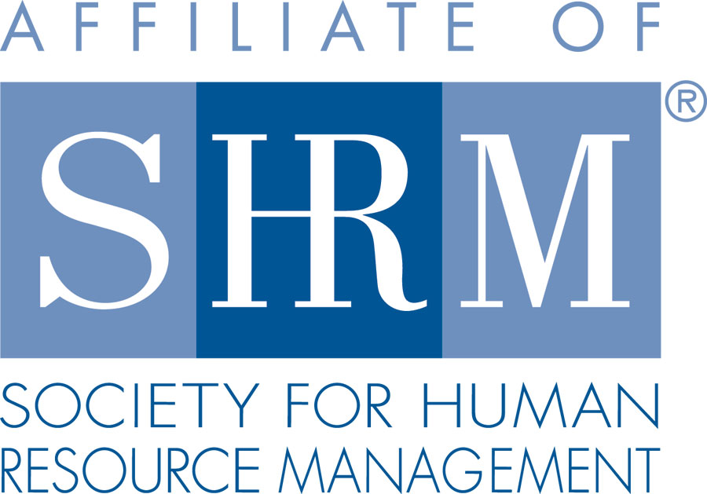
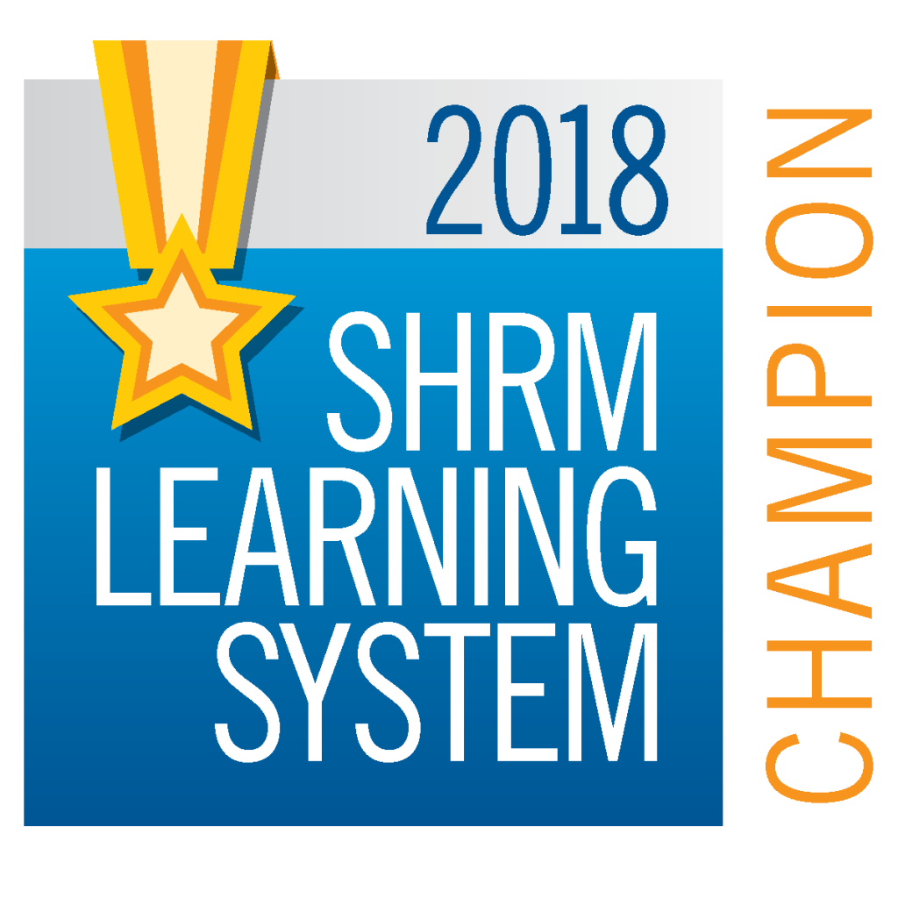
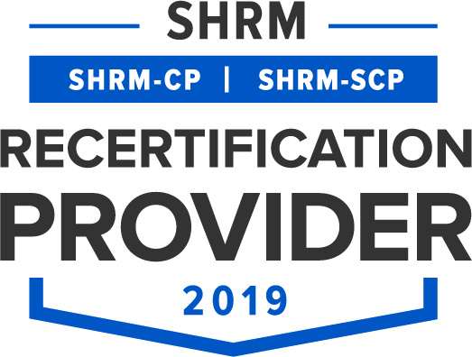

BERKS COUNTY CHAPTER #179
P. O. Box 55
Temple, PA 19560
Phone: 610-929-3678 www.berkspa.shrm.org

BOARD OF DIRECTORS MEETING MINUTES
January 15, 2019
Wyomissing Family Restaurant

Invitees: Shane Keller, Debbie Ramsey, Jenny Batista, Jessica Weaknecht, Krista Pauley, Whitney Rahman, Bob Orzechowski, Chuck Holder, Bill Gage, Susan Curtis, Denise Lee, Beth Berrett, Wendy Button, Audra Donato, Bonnie Gruber, Nic Thomas

Attendees: Debbie Ramsey, Christopher Holmes, Shane Keller, Whitney Rahman, Bob Orzechowski, Bonnie Gruber, Nic Thomas, Chuck Holder

- 7:36 am Debbie Ramsey and Shane Keller – Called to order
- Approval of the December 18, 2018 Board Meeting Minutes
- Review of January 2019 General Meeting Critiques -
- Treasurer’s Report
  - Update – Any new info on the card reader?
Opening Balance $
Income $
Expenses $
Ending Balance $
- Committees and Chairs:
- Administrator – Website (Wendy Button) Review Membership application
- BCTV (Bob O)
- Certification – Study Group (Bob O)
- Chapter of the Year (Jessica)
- Compliance (Susan Curtis)
- Diversity & Inclusion (Denise Lee) Review Symposium info
- Engagement Committee (Nic Thomas)
- Historian (Amy Heichel)
- Hospitality / Membership (Bill Gage)
- Legislative/A-Team (Whitney/Audra)
- Programming / Speaker Contact (Krista Pauley)
- Marketing
- Sponsorship / Community Relations (Chuck Holder) (Bonnie Gruber) Olivet’s Dinner update

- New Business:
  - National Conferences
March 12 – 14, 2019 – Employment Law & Legislative Conference – Washington (Whitney to attend)
  - Record Retention – Is anyone available to meet after work to get started?
  - Shape Report – has the report been submitted?
  - Scholarship – Review info

- Next General Meeting – The 4 Steps to Creating a Certified Bullying Free Workplace. Presented by Pam Gockley, CEO of Reputation Learning Center.
- Lunch and Learn – January 22 – Update on Wage and Hour, presented by Deb Franklin Esq.
- Next Board Meeting – February 19th – Wyomissing Family Restaurant.

