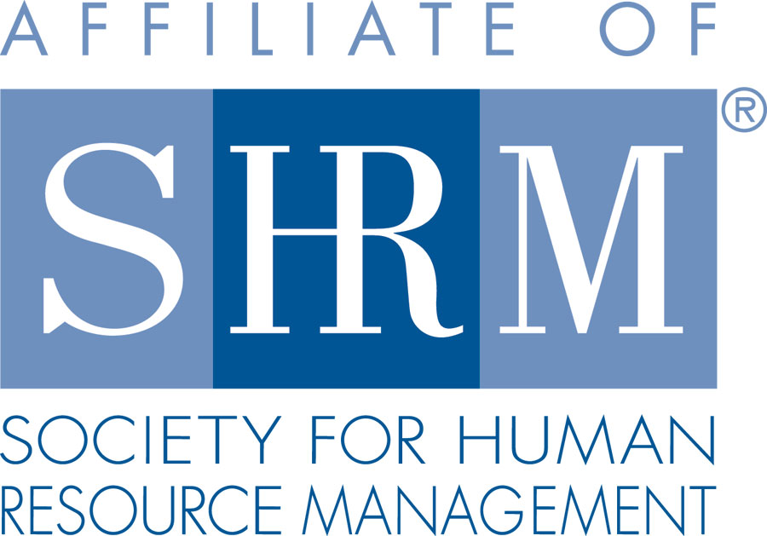 | BERKS COUNTY CHAPTER #179  P. O. Box 55  Temple, PA 19560  Phone: 610-929-3678 www.berkspa.shrm.org | 

BOARD OF DIRECTORS Meeting Minutes
June 24, 2019
Brickstone’s Mighty Fine Food & Spirits

Invitees: Shane Keller, Jenny Batista, Bonnie Gruber, Beth Shartle, Debbie Ramsey, Krista Pauley, Whitney Rahman, Bob Orzechowski, Chuck Holder, Bill Gage, Denise Lee, Beth Berrett, Wendy Button, Audra Donato, Nic Thomas, Susan Curtis

Attendees: Shane Keller, Debbie Ramsey, Jenny Batista, Whitney Rahman, Bob Orzechowski, Chuck Holder, Bill Gage, Denise Lee, Beth Berrett, Bonnie Gruber

- 5:34 pm – Shane Keller - Called to order
- Review of General Meeting Critiques:
- May 14, 2019 – Talent Acquisition: Bridging the Law and effective Practices, Jonathan Segal - was overwhelming terrific, Jonathan is always well received.
- Lunch & Learn – May 28, 2019 – Employee’s as Care Givers – 2 met, 8 exceeded – comments were positive, very timely, up-to-date subject matter.
- June 11, 2019 -
- Treasurer’s Report
  - Review & Approve Expenses and Budget – table till next Board Meeting
Opening Balance $23,209.94
Income $5,267.51 (high due to D&I Symposium registration and sponsorship)
Expenses $2,170.47
Ending Balance $26,306.98 (this will reduce with payout for D&I Symposium)

  - Member and Nonmember fee (monthly) – voted to remain the same
  - Annual Dues Charge- voted to remain the same
  - Card Reader – need to set-up online account, we have the reader.
  - Chapter Admin Fee – Board accepted request of increase and motion to grant was voted on and approved increase.
- Committees and Chairs:
- Administrator – Website (Wendy Button)
- CLIF report – has been submitted
- Any changes to Website – Everything is up-to-date, completed apps, taking training on updating SHRM website.

- BCTV (Bob O)
  - Chapter Involvement – Ask if anyone is interested to be involved in one of the sessions. 8 testimonials – putting on the website, will show before the meeting.
  - Last show did have some home viewers call in.
  - Fees, Sponsor - $100 producer’s fee and Chet continues to be the underwriter.
- Certification – Study Group (Bob O)
- Fall 2019/Spring 2020 classes 3 people are interested need 5 for discount.
- Scholarship Program – motion to move forward, motion & 2nd, motion carries. Looking for a commitment by participant to attend the study group sessions, scholarship for certification exam fees, recertification fees and possible exam materials. Criteria needs to be examined and scholarship is for participants out of pocket, not eligible if employer pays costs.
- Chapter of the Year (Jessica)
- Application due August 1st.
- Compliance (Susan Curtis)
- Account balance and compliance – Susan wasn’t there to report.
- Diversity & Inclusion (Denise Lee)
- June 25th Symposium – everything is ready, banner is finished, showed Board the brochure, made slides with the vendors/sponsors. 19 vendor tables. Great turnout for first time. Put funds into a savings account for future seminar/symposium.
- Engagement Committee - No Update
- Historian (Amy Heichel) – No Update
- Hospitality / Membership (Bill Gage)
- Goal to increase Membership – by 5%
- Goal to maintain Membership – maintain and sustain
- Mug order – 3 years since last order, will order 144 mugs
- Legislative/A-Team (Whitney/Audra) – Whitney contacting folks for Lunch & Learn Speakers, looking for one additional speaker for next round.
- Programming / Speaker Contact (Krista Pauley)
- Calendar is up-to-date and sent out.
- Any potential speakers should contact Krista Pauley
- PDC’s are covered
- Sponsorship / Community Relations (Chuck Holder)
  - Sponsorship seems down – Chuck states he just didn’t have the time and needed additional help…his workload was just too much.
  - Any potential sponsors should contact Chuck Holder or Wendy Button

- New Business:
  - Bank update – Jenny will have new signature cards at the July meeting.
  - Board job descriptions/list of duties/responsibilities – draft up the responsibilities this will help the next person coming into the position what they need to cover.
  - SHRM’s Getting Talent Back to Work Pledge – required to look at the pledge.
  - 19 months till 50 years as a Chapter
  - Volunteer Conferences
- August 3, 2019 – HR Change Agent Training – Carlisle, PA
- September 19 & 20, 2019 – PA SHRM State Conference – State College
- Next General Meeting - July 9, 2019 – PA Shared Work Program: An Innovative alternative to Employee Layoffs, presented by Sandra Catilao-Sanchez.
- Lunch & Learn – July 23rd – Unconscious Bias, presented by Denise Lee
- Next Board Meeting - July 16th at the Wyomissing Family Restaurant and Bakery.
- Motion to adjourn – 7:17 pm - unanimous

