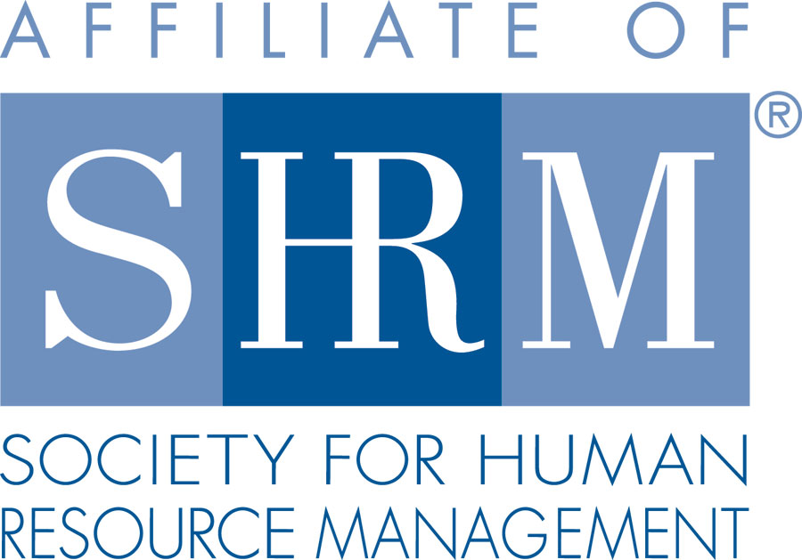 | BERKS COUNTY CHAPTER #179  P. O. Box 55  Temple, PA 19560  Phone: 610-929-3678 www.berkspa.shrm.org | 

BOARD OF DIRECTORS MEETING MINUTES
March 19, 2019
Wyomissing Family Restaurant

Invitees: Shane Keller, Debbie Ramsey, Christopher Holmes, Jenny Batista Jessica Weaknecht, Krista Pauley, Whitney Rahman, Bob Orzechowski, Chuck Holder, Bill Gage, Susan Curtis, Denise Lee, Beth Berrett, Wendy Button, Audra Donato, Bonnie Gruber, Amy Heichel, Nic Thomas

Attendees: Debbie Ramsey, Shane Keller, Bob Orzechowski, Bill Gage, Bonnie Gruber, Nic Thomas, Whitney Rahman, Chuck Holder, and Denise Lee

- 7:32 am Debbie Ramsey – Called to order
- Approval of the February 26, 2019 Board Meeting Minutes
- Review of February 2019 General Meeting Critiques – The February general meeting 60% met expectations. One critique was the number of handouts and them not being handed out all at once.
- Treasurer’s Report
  - Update – Any new information on the card reader – no update at this time.
Opening Balance $28,888.46
Income $1,044.00
Expenses $2,053.18
Ending Balance $27,879.28

- Committees and Chairs:
- Administrator – (Wendy Button) – Discuss Survey Monkey vs. SHRM Website – Recommends SHRM’s Website, the cost of Survey Monkey and the amount of survey’s that we send out isn’t economical. Need to ask Wendy if there are any restrictions/limits on the SHRM’s Website.
- BCTV (Bob O) – Handbook and Policies had a caller, the show seemed to go fast. 14th year of SHRM programs on BCTV.
- Certification – Study Group (Bob O) – Moving right along. Last week was their 7th class. April 11th is the last class. Wondering if anyone who couldn’t make a class if they should be able to be on a Conference Call to hear what is being discussed? On average 6 of the 8 students show up weekly.
- Chapter of the Year (Jessica) – No Update from Jessica, Bob mentioned that he gave her several applications.
- Compliance (Susan Curtis) – 2018 Annual Statement, 990-EZ
- Diversity & Inclusion (Denise Lee) – Denise presented some information on the Symposium. Looking at April 30th, calling and getting pricing for various locations. Discussed having three speakers, having outside sponsorship to help with the cost of speakers. Probably will have limited seating, depends on location. The Symposium would be a half day program.
- Engagement Committee (Nic Thomas) – January meeting Nic was late getting to the meeting so he didn’t have the new members table. There were a couple new members to greet. Nic would be willing to meet with the Engagement Committee to discuss combining the Engagement and the Marketing Committee. Then propose the option with the Marketing Committee. Engagement Committee is looking at brainstorming on how to get the non-attendee’s to attend meetings, what is holding them back. Really want to work on getting the SHRM name out there and to have an understanding of what our local Chapter has to offer.
- Historian (Open) – No Update.
- Hospitality / Membership (Bill Gage) – We had 4 new members this month. Worked with Berkshire Country Club and agreed on a 50 cent increase. With this increase we do not have to raise the monthly meeting cost. Since the Christmas Party was cancelled due to low attendance a suggestion was made to have a Spring Social which would include the installation of the new officials. We could have this inside with a possibility if the weather was nice having it open to the outdoors. Locations: BCC, Stokesay Castle (Knights Pub).
- Legislative/A-Team (Whitney/Audra) – No update
- Marketing Update – Discuss the possibility of the Marketing Committee and the Engagement Committee merging.
- Programming / Speaker Contact (Krista Pauley) – Updated Speaker Listing distributed. Krista will contact Jonathan concerning the May Meeting. Most speakers have speaking fees, it is becoming difficult to get speakers that don’t charge.
- Sponsorship / Community Relations (Chuck Holder) – Chuck mentioned about providing a 30 second video after the meeting asking the meeting sponsor, what they like about sponsoring a SHRM Meeting. Discussion about having a community service activity for high school students, maybe an essay on D&I, with a reward for the winning essay.
- New Business:
  - Volunteer Conferences
August 3, 2019 – HR Change Agent Training –Carlisle, PA
September 19-20 – PA SHRM State Conference, State College
  - Secretary Nomination Process – Alex Goodman & Beth Shartle have been nominated
  - Scholarship – Table till next board meeting
- Next General Meeting – April 9th – Disability Awareness: How HR Can Ensure Onboarding, Retention & Future Planning, Presented by Vondol Hammond & Lavinia Garcia Ritter.
- Lunch and Learn – March 26th – Privacy Issues in the Workplace, Presented by Whitney Rahman Esq.
May 28th – Employees as Caregivers: What Employers Need to Know, Presented by Kevin Moore.
July 23rd – Unconscious Bias, presented by Denise Lee.
- Next Board Meeting – April 16th, 2019 at the Wyomissing Family Restaurant.

- Motion to adjourn – 8:46 am – Bob Orzechowski and Jenny Batista

