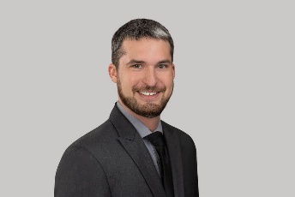
Rick Schlegel Bio

Rick Schlegel came to EHD in 2017 and has ample prior experience in the Risk and Saftey field. Before coming to EHD, Rick earned his Bachelors degree in Occupational Safety and Environmental Health from Millersville University. He then worked for Bosch Rexroth as a Safety, Health and Environmental intern and at CHEP Recycled Pallet Solutions as a Safety Coordinator for four years. Rick brings his ample knowledge of OSHA regulations, experience with industrial hygiene requirements and a vast knowledge of various aspects of safety programs. His main goal at EHD is to provide our customers with the best tools and knowledge in order to further their safety programs and reduce their risk.

