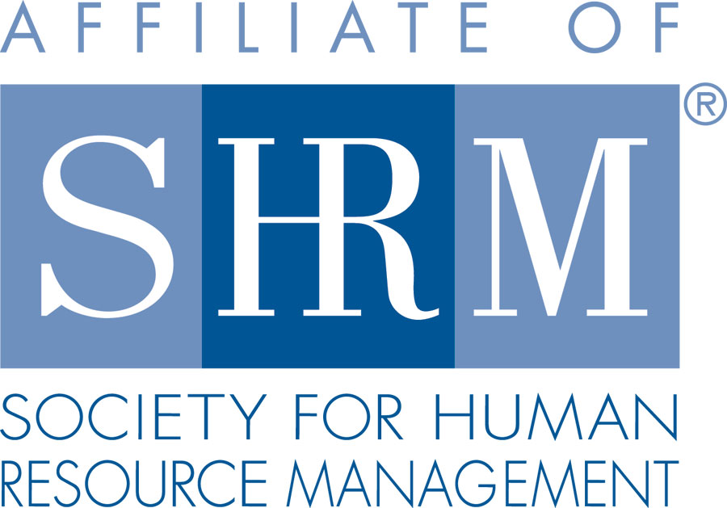 | 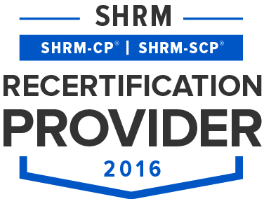 | 

BERKS COUNTY CHAPTER #179
P. O. Box 55
Temple, PA 19560
Phone: 610-929-3678 www.berkspa.shrm.org

BOARD OF DIRECTORS MEETING MINUTES
January 17, 2017
7:30am – Wyomissing Family Restaurant

Present: Marguerite Kline, Krista Pauley, Jessica Weaknecht, Shane Keller, Debbie Ramsey, Christopher Holmes, Whitney Rahman, Bob Orzechowski, Chuck Holder, Bill Gage, and Denise Lee.
Absent: Susan Curtis, Beth Berret, Bonnie Gruber, and Wendy Button.

Jessica Weaknecht, Chapter President, called meeting to order at 7:32 AM.

- Jessica motioned for Approval of Board Meeting Minutes from the December meeting. Motion approved by Krista Pauley with a second by Marguerite Kline.
- Review January General Meeting critiques – Jessica reported that the comments were positive overall. The eggs were even cooked well this time. The only negative was that the room was a little cold.
- Treasurer’s Report – Debbie Ramsey reported the following budget numbers via email on 1/23/17:
  - Starting balance = $14, 749.55, Expenses = $6,672.42, Income = $865.00, Ending balance = $8,942.13
- Committees and Chairs:
- Administrator – Website (Wendy Button) – no report
- BCTV - Bob O. reported that the last show was Tuesday 1/10/17. March 14th will be the next broadcast. Bob also pointed out that our Chapter has been broadcasting for 13 years and running.
- Certification – Study Group - Bob O. reported that the study sessions will be held from February 9th through May 11th (with no class on April 13th). The mock exam will be held on May 11th. 9 students have signed up already. We have 5 confirmed facilitators so far as well. However, Bob O. welcomes more.
- Status on facilitators
- Compliance (Susan Curtis) – no report
- Diversity & Inclusion - Denise Lee reported that she will soon be kicking off a 9 member committee meeting to be held at Mosteller & Associates. She is still developing the final agenda.
- Engagement Committee - Bob O. reported that the couple committee members at the table in the lobby for General meetings has been well received particularly with improved member awareness and engagement. The committee will be taking on membership renewal campaign efforts in March.
- Historian (Open) – no report
- Hospitality / Membership - Bill Gage reported that the Valentine candy from Palmer is ready for the next General meeting on February 14th. Bill was able to negotiate with BCC to decrease our A/V rental fee from $100 per meeting to $50 per meeting. BOD members found this to be acceptable and thanked Bill for his successful efforts.
- Legislative - Whitney Rahman reported that she will determine whether Andy and Kevin are interested in conducting another series of the Lunch & Learns for 2017. Krista observed that many who attended the Lunch & Learn sessions because they have a hard time getting to the breakfast meetings. Group discussed whether the sessions should be 1.5 hours instead of 1 hour. A survey will go out to the membership to check their preference.
- Programming / Speaker Contact - Krista Pauley reviewed the annual speaker and topic handout with the BOD showing that other than March, there are speakers and topics for February through May 2017. Krista also handed out examples of topics other chapters have presented for the Board to consider holding similar ones for March and for the last part of 2017.
- Special Projects
- Shape Report – Shane Keller reported that the Shape Report is complete and has been submitted. Given that sponsoring National SHRM remains an area our Chapter needs to do for the Shape Report, the BOD have confirmed that Chuck Holder will hold a wine networking event this year to benefit National SHRM. It was suggested to hold a gift basket drawing at that meeting to increase the funds collected.
- New Business
- General Survey – will go out and will include a question or two on the Lunch & Learns for 2017
- Nonmembers attending – limit on times can attend to be determined at a later date.
- Secretary recruit & requirements of BOD positions – Beth Shartle may still be interested. Candidates will need to be submitted by March in order to have enough time for election process. The May general meeting should start earlier (around 0715 or so) to swear in the new officers.
- Membership dues to the Chamber went up to $462. Chuck will speak with the leaders of the Chamber of Commerce to see if we can benefit more from the dues.
- Officer Job Descriptions – Jessica asked the BOD members to review the officer JDs so they are accurate for the incoming candidates. The JDs will be reviewed during the February BOD meeting.
- Sponsorship – Chuck will provide a list of past sponsors for reference. Chuck said the sponsors would like to know the head count in advance of the meetings. Chuck also reported that most of the sponsors over the past six months have been satisfied with their exposure to our membership.
- Bob O, suggested we offer a discount for the April meeting so we can pack the room for the National SHRM speaker. Wendy will be asked to send a special email blast encouraging attendance. Krista will see if she can expand advertising to include the HR Summit attendees.

- Next General Meeting is February 14, 2017 – Speaker: Dale Glacken – What’s new in OSHA – An update on standards & inspection.
- Next Board Meeting – February 21, 2017 – Wyomissing Family Restaurant
- Jessica made a motion to adjourn at 8:57 AM which was approved by Bob O. with a second by Shane Keller.

Minutes respectfully submitted by Christopher Holmes, Secretary.

