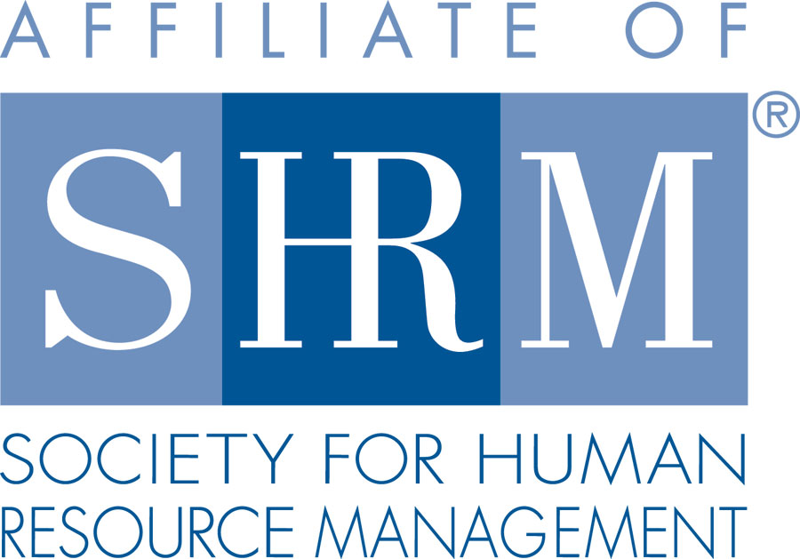 | 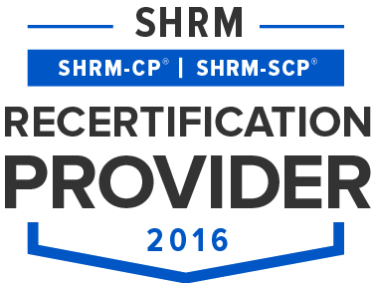 | 

BERKS COUNTY CHAPTER #179
P. O. Box 55
Temple, PA 19560
Phone: 610-929-3678 www.berkspa.shrm.org

BOARD OF DIRECTORS MEETING MINUTES
April 18, 2017
7:30am – Wyomissing Family Restaurant

Present: Krista Pauley, Jessica Weaknecht, Shane Keller, Debbie Ramsey, Christopher Holmes, Whitney Rahman, Chuck Holder, Bill Gage.
Absent: Marguerite Kline, Bob Orzechowski, Susan Curtis, Denise Lee, Beth Berret, Bonnie Gruber, Wendy Button

Jessica Weaknecht, Chapter President, called the meeting to order at 7:32 AM

- Jessica made a motion to approve the Board Meeting Minutes from the March meeting. Motion was approved by Shane Keller with a second by Debbie Ramsey.
- Review April General Meeting critiques – Overall comment themes were that the speaker and topic were very good. Runny eggs came up again. Chapter raised $109.00 from the basket raffle for the National SHRM foundation. BOD members will consider holding raffles to benefit local charities going forward as long as the raffles do not take place too frequently to require a games-of-change license. The Reading Eagle published a nice article of our event. Bob O. needs to let the BOD know how much we owe for the speaker’s travel and accommodations. The BOD members have agree to donate the recommended $500 for Elissa to come out and speak for our Chapter.
- Treasurer’s Report
  - Beginning Balance = $21,515.55
  - Income = $4,845.00
  - Expenses = $2,214.82
  - Ending Balance = $24,145.73

- Committees and Chairs:
- Administrator – Website (Wendy Button) – No report
- BCTV (Bob O) – No report
- Certification – Study Group – Krista Pauley is the next scheduled instructor. The program is nearly complete.
- Compliance (Susan Curtis) – No report
- Diversity & Inclusion (Denise Lee) – Denise forwarded her committee minutes to the BOD and asked the Board to address the following 3 items: 1) Determine the D&I mission statement. The BOD is fine with the mission statement as long the as the words “among other things” is added before the statement about regardless of age, race, gender… 2) The BOD are fine with the survey going out, they would just like to review it first. 3) With regard to the members being able to pay for meetings on-line, the BOD recalls the Pay Pal fee being too cost prohibitive.
- Engagement Committee – Jessica reported in Bob’s absence that Bob’s committee members contacted 30 non-renewing members to learn that many have moved out of the area or have accepted jobs outside of the HR profession. A few others mentioned cost issues and their ability to attend the meetings were factors. Bob estimates that 3-4 have agreed to renew as a result of their efforts. The committee plans to reach out to those current members who have not attended a meeting since January of 2017.
- Historian (Open) – No report
- Hospitality / Membership - Bill Gage reported that the manager of the Berkshire Country Club (Chad) will speak for five minutes during our next meeting about their services. Bill reported that there has been an average of five new members per meeting over the past few months. Wendy will start to send a thank you letter to each guest telling them about our Chapter and encouraging them to join. Bill also reported that Wendy forwarded an overview of our Chapter via email recently.
- Legislative (Whitney Rahman)
- Language for diversity mission statement – See discussion above in the D&I topic.
- Programming / Speaker Contact - Krista Pauley reported that she is experiencing some challenges securing speakers for next year. Many have not returned her calls and others are starting to charge a fee. The BOD discussed various options for speakers and topics. Members are asked to let Krista know if they know of anyone who can speak on HR topics. The BOD confirmed its decision not to renew its membership fees to the Chamber of Commerce at this time.
- Space for Lunch & Learns – Confirmed with the Wyomissing Family Restaurant.
- Feedback on updated form – Approved
- Sponsorship - Chuck Holder reported that the next sponsor is scheduled for the September meeting. Chuck shared how disappointed he was that the April meeting sponsor did not show up and did not pay for the sponsorship.
- Community Relations Imitative – Chuck has been trying to start a grass roots effort to change the image of the City of Reading. He was granted permission to send a survey to the general membership seeking their level of interest.
- New Business
- Secretary Nominations – The voting period ends April 24th. The BOD is recommending that starting next year the candidates running for Secretary get a few minutes to share a little about themselves in front of the general membership.
- Planning Meeting – Shane will schedule the meeting for late May and confirm.
- CPEP Program – The Chapter Promotion E-mail Program (CPEP) will be discussed at a later date.
- Providing Handouts Prior to Meeting? – When made available early enough, Wendy will forward the speaker topic materials (PDF) to those members who have registered for the respective meeting(s).
- State Meetings:
  - May 4th – in person meeting at Harrisburg L&L conference (Jessica attending)
  - July 28th in person State meeting and July 29th – PA SHRM Leadership Conference. All Board and committee members are invited to attend. Conference is free.
  - September 20th – in person State meeting. September 21-22 State Conference (Shane attending)
  - November 16-18 – SHRM National Leadership Conference, Washington D.C.
- Next General Meeting is May 9, 2017 – Speaker: Jonathan Segal – Gender Pay Gap
- Next Board Meeting – May 16, 2017 – Wyomissing Family Restaurant
- Jessica made a motion to adjourn at 8:42 AM which was approved by Krista Pauley with a second by Chuck Holder.

Minutes respectfully submitted by Christopher Holmes.

