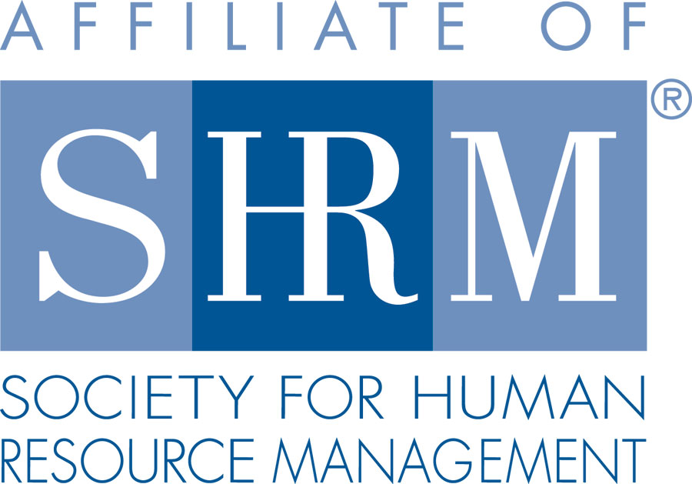 | 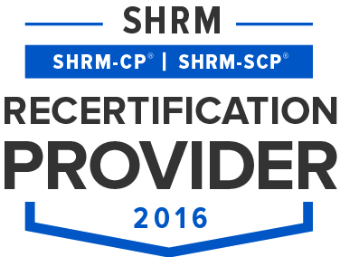 | 

BERKS COUNTY CHAPTER #179
P. O. Box 55
Temple, PA 19560
Phone: 610-929-3678 www.berkspa.shrm.org

BOARD OF DIRECTORS MEETING MINUTES
February 21, 2017
7:30am – Wyomissing Family Restaurant

Present: Marguerite Kline, Krista Pauley, Jessica Weaknecht, Shane Keller, Debbie Ramsey, Christopher Holmes, Whitney Rahman, Bob Orzechowski, Chuck Holder, Bill Gage, and Denise Lee.
Absent: Susan Curtis, Beth Berret, Bonnie Gruber, and Wendy Button.

Jessica Weaknecht, Chapter President, called the meeting to order at 7:30 AM.

- Jessica made a motion to approve the Board Meeting Minutes from January. They were approved as written by Krista Pauley and Marguerite Kline.
- Review of February General Meeting critiques – Jessica reported that the responses were good overall. Some of the suggested future topics listed were performance appraisals, disciplinary action, and recruitment.
- Treasurer’s Report – Debbie Ramsey reported the following budget figures and shared that the price at the Wyomissing Family Restaurant has gone from $11.00 to $13.66 per person. Group feels we are fine with increase because we still make a profit. However, Krista Pauley will double check the critiques from the last Lunch & Learn meeting to make sure.
  - Beginning Balance $14,642.01
  - Income $6,769.00
  - Expenses $1,073.12
  - Ending Balance $20,337.89
- Committees and Chairs:
- Administrator: Website – Jessica reported that Wendy Button sent out a second notice to members about dues. The Secretary Election time frame is upon us and Wendy will be sending communications as needed. Wendy will also be e-mailing the annual survey data in late March.
- BCTV - Bob O. reported that March 14th is the next broadcast which will cover recruitment and selection. Bob is still seeking a couple participants for the show.
- Certification: Study Group – Bob O. reported that the first 2 classes are completed. All nine attended. Training dates and materials are lined up for the remaining classes.
- Compliance (Susan Curtis) – no report
- Diversity & Inclusion - Denise Lee reported the committee has ten members and they are already discussing assignments. They will be reviewing the 2015 D&I survey results. Denise will be providing monthly updates during the general meetings. Denise will work with Wendy to update the D&I information on the website. She is leading their first meeting on February 28th. They are planning to review what other D&I committees are doing. Denise asked if the committee members must be local chapter members. The BOD stated that it is a preferred condition.
- Engagement Committee - Bob O. reported that the new member table during the general meetings seems to be well received. The Engagement Committee plans to contact members personally who have not attended the meetings for three consecutive times.
- Historian (Open) – no report
- Hospitality / Membership - Bill Gage asked whether our Chapter can accept Tony Sabanos as a member. The BOD agreed the can have an Associate Member status.
- Legislative - Whitney Rahman reported that all three of the next Lunch & Learn sessions are confirmed.
- Programming / Speaker Contact - Krista Pauley reviewed the 2017/2018 speaker schedule with the BOD members. She pointed out that the speakers are lined up through May of this year but that June and forward need to be booked.
- Sponsorship - Chuck Holder reported that the March, April, and May sponsors for our general meetings are in place. Chuck is nearly finished with a spreadsheet showing sponsorship historically, currently, and into the near future. April 11th is still the date Chuck is planning to hold the Chapter fund raising event at Ridgewood Winery. Chuck will let the BOD members know what he can provide for a prize drawing during o April 11th.
- Special Projects – Chuck shared that community relations initiatives through the Business Workforce Coalition are still being explored. Shane reported that we have over 100 members on our Chapter’s LinkedIn site.
- New Business
- Secretary recruit & requirements of BOD positions – Jessica reported that actions are underway to support these requirements.
- Veterans Affairs Job Fair – Jessica reported that this will be held at the Crowne Plaza on May 31st. We can decide who will be attending and when on behalf of our Chapter during the next BOD meeting.
- April Meeting – Our Chapter is fortunate to have the VP of National SHRM coming to speak at our April General Meeting. Bob O. will look into whether we should be covering her hotel and mileage expenses.
- Coverage for April meeting – Jessica will be out of the country during the April meeting. Shane said he will lead the April meeting in Jessica’s absence.
- Mark Shearer and his team are still working on our new microphone issue. The cable we need should be in soon.
- Next General Meeting is March 14, 2017 – Speaker: Whitney Rahman – An “HR” Nightmare: Harassment and Retaliation in the Workplace
- Next Board Meeting – March 21, 2017 – Wyomissing Family Restaurant
- Jessica made a motion to adjourn at 8:35 AM which was approved by Shane Keller with a second by Debbie Ramsey.

Minutes respectfully submitted by Christopher Holmes, Secretary.

