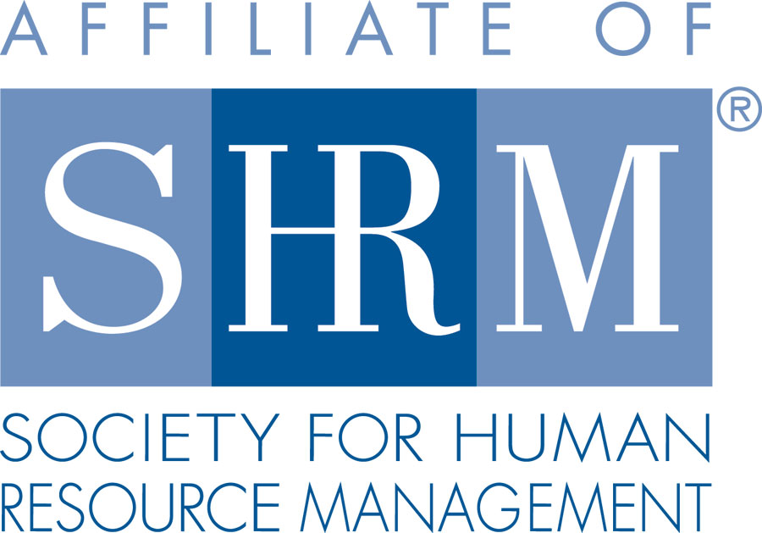 | 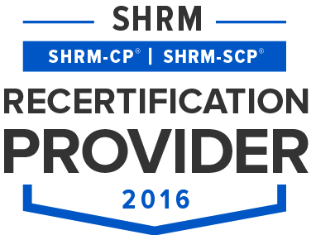 | 

BERKS COUNTY CHAPTER #179
P. O. Box 55
Temple, PA 19560
Phone: 610-929-3678 www.berkspa.shrm.org

BOARD OF DIRECTORS MINUTES
March 21, 2017
9:00am – Berkshire Country Club

Present: Marguerite Kline, Krista Pauley, Jessica Weaknecht, Shane Keller, Christopher Holmes, Chuck Holder, Bill Gage.
Absent: Debbie Ramsey, Whitney Rahman, Bob Orzechowski, Susan Curtis, Denise Lee, Beth Berret, Bonnie Gruber, and Wendy Button.

- Jessica Weaknecht, Chapter President, called BOD meeting to order at 9:15 AM and made a motion to approve the minutes from the February meeting which were approved by Shane Keller with a second by Marguerite Kline.
- Review March General Meeting critiques – Shane has them and will email to the BOD members to review.
- Treasurer’s Report – No report. Financials will be reported next month.
- Committees and Chairs:
- Administrator – Website: Jessica reported that three Secretary Nominations came in so far. Voting will be arranged through Survey Monkey.
- BCTV (Bob O) – Report given during General meeting.
- Certification – Study Group (Bob O) – Report given during General meeting.
- Compliance (Susan Curtis) – No report
- Diversity & Inclusion (Denise Lee) – no report
- Engagement Committee (Bob O) – no report
- Historian (Open) – no report
- Hospitality / Membership - Bill Gage reported that 5 new members joined in March and he is aware of a few more who appear interested in joining us in April.
- Legislative (Whitney Rahman) – No report
- Programming / Speaker Contact - Krista Pauley asked the BOD members to review the application process she provides anyone who would like to present for our Chapter. Feedback can be provided via email or during the next meeting. Discussion arose whether our Chapter should consider hosting webinars.
- Sponsorship - Chuck Holder will be moving our Chapter’s wine event from April 11th to May.
- Special Projects – Shane reported that 136 members are on our Chapter LinkedIn site which provides a link to our application for non-members.
- New Business
- Secretary Nominations – Reported above.
- State Meeting – Conference Call held on 3/17/17
  - Jessica provided some updates from call in which she participated. She went on to share the following upcoming events to the BOD as well.
  - May 4th – in person meeting at Harrisburg L&L conference
  - July 28th in person State meeting and July 29th – PA SHRM Leadership Conference. All Board and committee members are invited to attend. Conference is free. Discussion arose whether our Chapter should register for the Chapter of the Year Award.
  - September 20th – in person State meeting. September 21-22 State Conference
  - November 16-18 – SHRM National Leadership Conference, Washington D.C.
- April Meeting – Elissa O’Brien
- Bob O. is working with Elissa to help take care of her travel arrangements, etc.
- Gift baskets will serve as fund raiser raffles during the April General Meeting.
- Next General Meeting is April 11, 2017 – Speaker: Elisa O’Brien – Six Key Elements of an Effective Talent Acquisition
- Next Board Meeting – April 18, 2017 – Wyomissing Family Restaurant
- Jessica made a motion to adjourn at 9:45 AM approved by Marguerite Kline with a second by Chuck Holder.

Minutes respectfully submitted by Christopher Holmes, Secretary.

