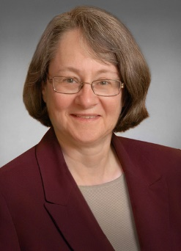

**S. Whitney Rahman**

Whitney is a shareholder attorney at Blakinger Thomas, PC in Lancaster and is the Chair of its Employment and Labor group. She advises employers on all aspects of employment and labor law, and handles issues relating to such diverse areas as independent contractor relationships, discrimination, harassment, retaliation, employer best practices, management training, collective bargaining, wage and hour issues, wrongful discharge and the Family and Medical Leave Act. She handles cases for clients in federal and state courts, and before federal, state, and local agencies, as well as in alternative dispute resolution settings. Whitney also represents landlords and owners with respect to fair housing matters, including discrimination claims under federal and state law.

Whitney is a frequent writer and speaker to business associations, bar associations and human resource groups. She has presented to groups including various chapters of the Society for Human Resource Management, local chambers of commerce, the National Association of Housing and Redevelopment Officials, and local chapters of the American Business Women’s Association. Whitney has also written articles for various trade publications.

Whitney graduated from Columbia University School of Law in New York City, where she was a Harlan Fiske Stone scholar and a member of the editorial board of the Columbia Law Review. She received her Bachelor of Arts degree, summa cum laude, from Moravian College in Bethlehem, Pennsylvania. Whitney has been a member of national SHRM and Berks SHRM Chapter #179 for more than 20 years and has been the legislative chairperson of Berks SHRM Chapter #179 for several years. She is a Charter Member of the Women Excelling (WE) Chapter of ABWA, and a member of the Building Industry Association of Lancaster County.