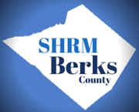
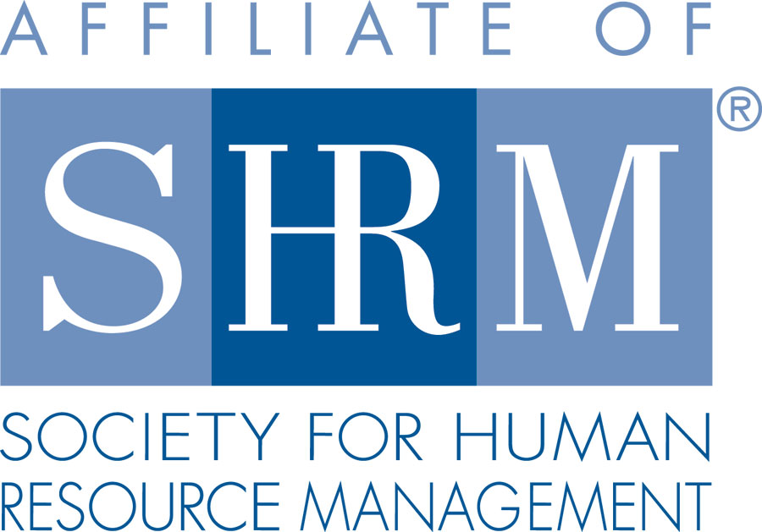

Berks County Chapter #179
SHRM Meeting Sponsorship
Opportunities Form

WHY SPONSOR WITH BERKS COUNTY SHRM?

The Berks County SHRM Chapter is an award-winning affiliate of the Society for Human Resource Management (SHRM). Founded in 1972, Berks County SHRM continues to provide professional development and networking opportunities for the area's human resource practitioners. Today, the organization is comprised of over 185 members from the greater Berks area. Our strength is in the diversity of membership which ranges from students just entering the profession to the most senior human resource executives in the region.

Berks County SHRM's vision is to be the primary advocate and resource for advancing the HR profession and its value in the greater Berks community. The mission of the organization is to provide knowledge, services and leadership to our members and the professional community by promoting current trends, best practices and new models that will stimulate individual and organizational success. Visit our website for more information www.berkspa.shrm.org. We offer exposure to an organization that allows for a variety of growth opportunities and rewarding recognition.

Sponsorship Information and Questions-
Please contact: Tamara DeLoretta at (610)858-7648 or tamara@hubricresources.com

The individual meeting sponsorship rate for a Berks SHRM Meeting Sponsorship is $300.00 per company, per in-person SHRM meeting and $125.00 for virtual meetings. Previous sponsors will receive a $50.00 discount for sponsoring again.

INDIVIDUAL MEETING SPONSORSHIP (Limit One Sponsor per Meeting)
- Meeting announcement recognition and listing
- Web hyperlink & logo (if provided) for your company for the three weeks leading up to the meeting on our website
- Email blast to members of “Sponsor Spotlight” sharing information on your company as provided by you
- Display table at meeting and literature (1 page flyer) at all tables
- Up to 5 minutes to address members at start of meeting from podium
- Sponsor can also introduce the meeting speaker
- Sponsorship includes 2 SHRM meeting fees
- Display box for meeting participants to drop their business card for follow up info from speaker

Company Name: ___________________

Contact Person: ____________________________________ Phone: __________________________________

Email Address: _____________________________________

Mailing Address:

Website Address: _____________________________________________________________________________

Month Sponsoring (if known) : _______________________________________________

Upon finalization of sponsorship, you will receive an invoice via email for the sponsorship fee along with payment options.
Revised 8/9/23

